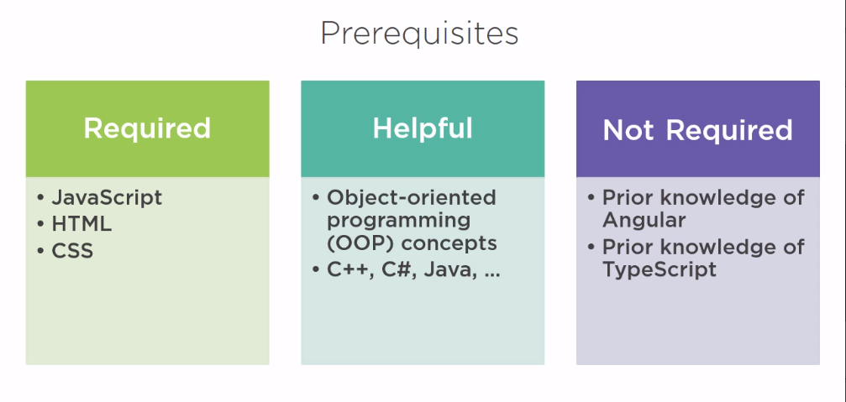

**What is Angular?**

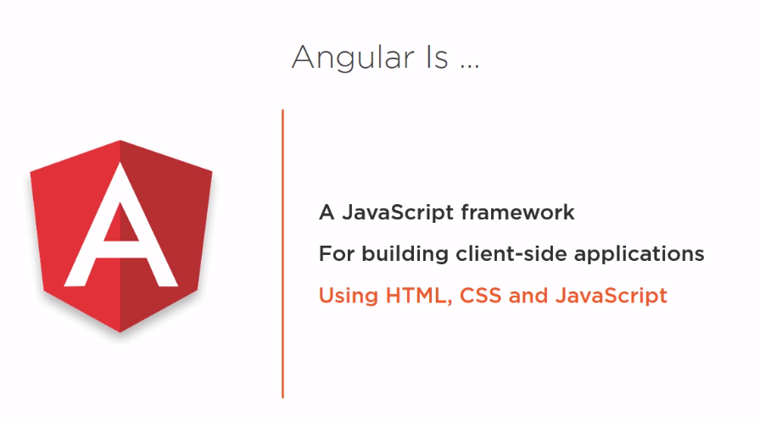

Angular is a Javascript frameworks for building Client Side Application using HTML, CSS and JavaScript.

**Why Angular?**

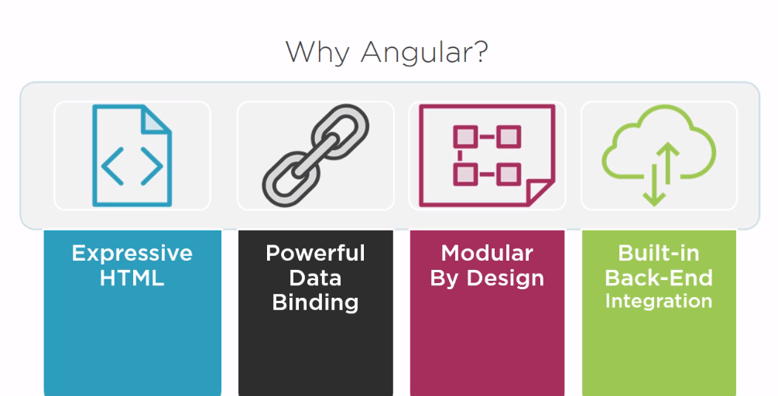

* Angular makes our HTML more Flexible. By the help of Angular HTML can be power up with features like if conditions, for loops, local variables.
* Angular has powerful data binding. We can easily display fields with data model, track changes and process updates from the users.
* Angular is modularized by design. Our apps become building blocks which makes it easier to create and reuse content.
* Angular has a built in support for communication with a backend service. It makes it easy for our web application to integrate with a back-end service, to get and post data or execute server-side business logic.

**Why Angular when we have Angular JS?**

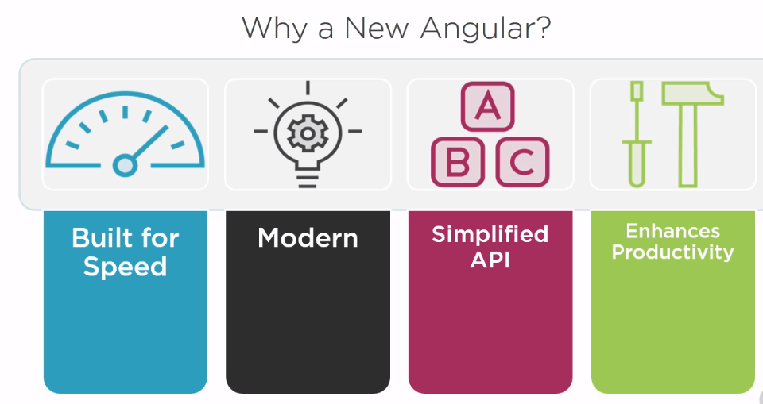

* Angular is built for speed. It has faster initial load, faster change detection and improved rendering time.
* Angular is modern. It takes advantages of features provided in the latest JavaScript standards and beyond such as classes, modules and decorators, yet it supports Legacy browsers.
* Angular has a simplified API, it has fewer built in directive to learn, simpler binding and a lower overall concept count.
* Angular enhances our productivity to improve our day-to-day workflow.

**Anatomy of an Angular Application**

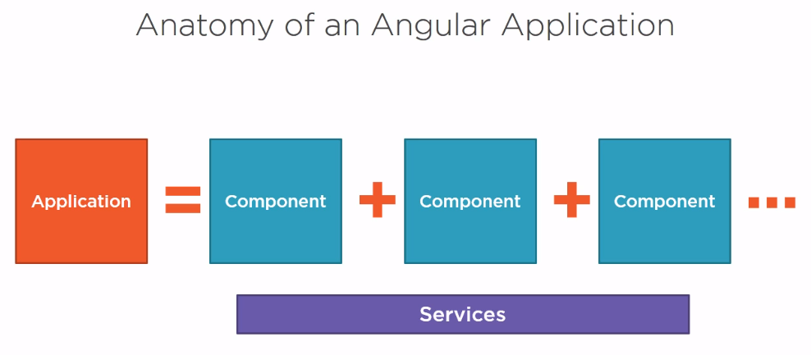

* In Angular an app is a set of components and services that provide functionality across those components.
* An Angular component is a template which is the HTML for the user interface fragment defining a view for the application. Add to that a class for the associated with the view. The class contains the properties or data elements available for use in the view and methods, which perform actions for the view such as responding to a button click.
* A component also has metadata, which provides additional information about the component to Angular. It is this metadata that identifies the class as an Angular component. So a component is a view defined with a template, its associated code defined with a class, and additional information, defined with metadata

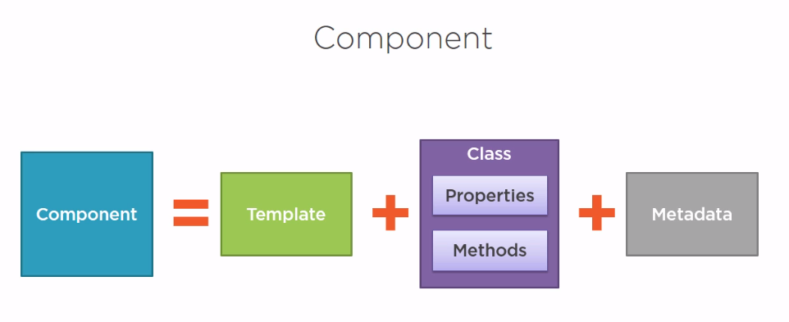

**Angular Modules**

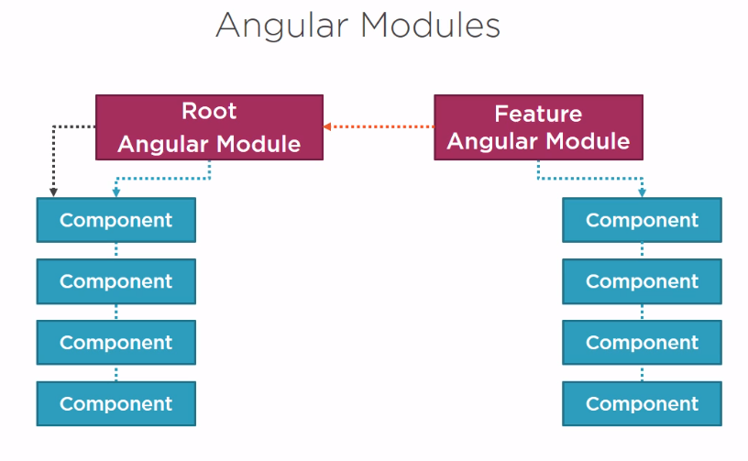

* Angular modules help us organize our application into cohesive blocks of functionality. Every Angular has at least one Angular module called the application’s **root Angular module.**
* An application can have any number of additional Angular modules including features modules that consolidate the components for a specific application features.

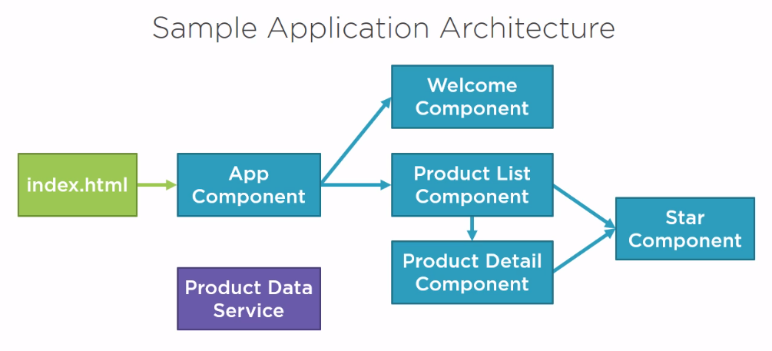

**Selecting a Language**

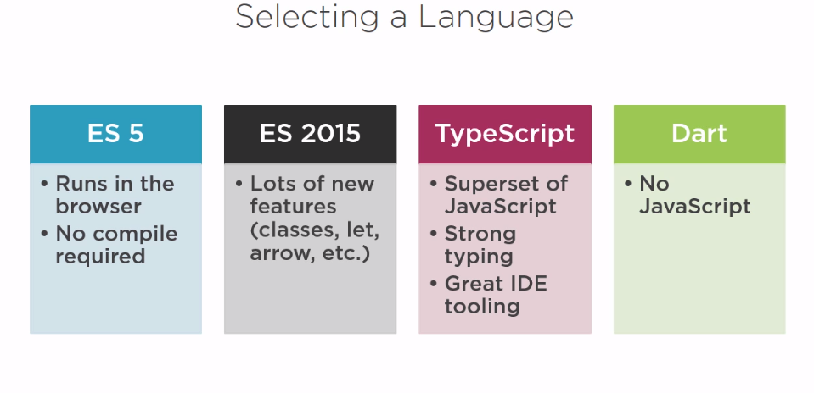

Note:

* We will go for Typescript

What is TypeScript?

* It’s a open source language
* Superset of JavaScript
* Transpiles to plain JavaScript
* It is strongly typed
  + Every variable, function and function parameter can have a data type.
  + By using TypeScript type definition files (*.d.ts) it determines the appropriate types when using javascript library that are not strongly type.
* It has class based object-orientation
* It implements classes, interfaces and inheritance

**Setting Up Our Environment**

1. Install NPM
2. Set up your Angular App

**What is npm?**

Npm stands for node package manger. It’s a command line utility. That interacts with the repository of open source projects. Using npm we can install libraries, packages and applications along with there dependencies. We need npm to install all the required libraries for angular and to execute the script to transpile our code and launch our angular application.

* Download and install npm

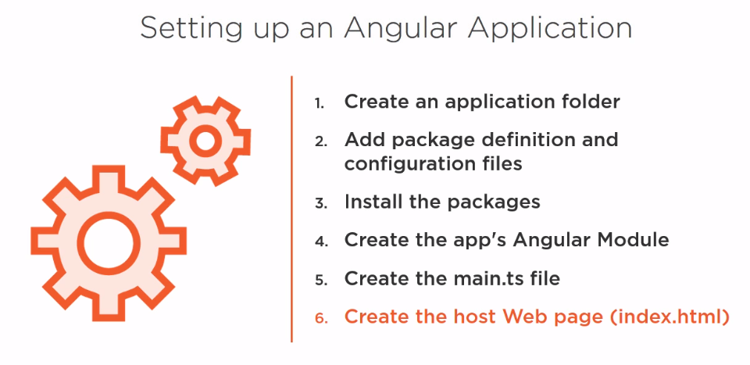

We can do all these steps one by one manually but it can lead to errors. To save our self from the manual labor we can use Angular CLI.

**Angular CLI** is a command line tool for generating the setup files and boiler plate code for an angular application. The CLI also generate components, modules, services and other files and it can do many more things.

**To install Angular CLI:** npm install -g @angular/cli

To make it much more simpler install **Angular IDE CI**

Commands to Create Angular Project:

ng new my-dream-app

cd my-dream-app

ng serve

**Workspace Structure for Angular**

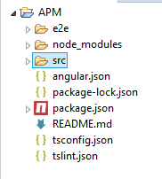

**src**: All the source files will be present inside the folder. Inside src there will be an app folder (src -> app) which contain the source file specific for our application. We can also have sub folders inside the src for major features.

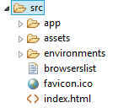

The other files are configuration and setup files:

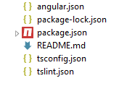

Before we run our application we need to install the required library for our application and all the library are defined in **package.json** file.

Note:

* To check the npm version type ‘npm –v’ in the terminal.
* Angular required minimum >=5.5.1 version of npm to work with
* To install the libraries using npm:
  + Navigate inside the project
  + Type: npm install
* It will generate a node_modules directory which will contain all the required libraries.

To start the application type: npm start (this will run the start script in the app).

**If things are not working fine, make sure that the npm is installed correctly.**

To stop the server, in the terminal type: **ctrl + c**

**What is a module?**

Module helps us to Organize the code and solve the problem of Namspaces.

In ES6 (ES 2016) Modules looks like this:

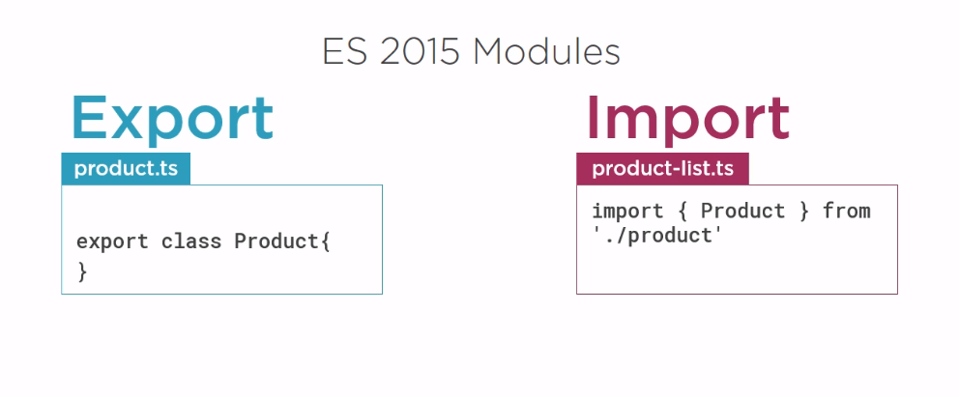

In ES 2015 a module is a File or File is a module.

**Note:**

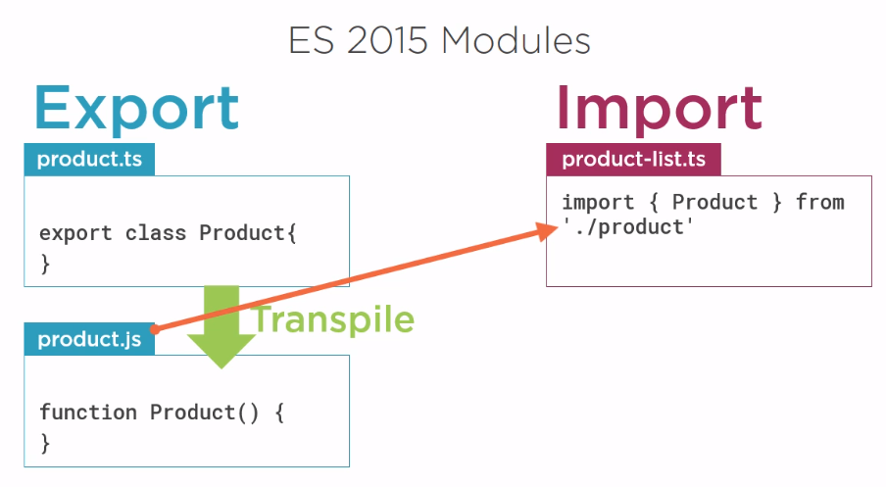

When we compile a **.ts** file it will transpile to **.js**. So, in the runtime we are importing a **.js** file. But, we don’t mention the extension anyway.

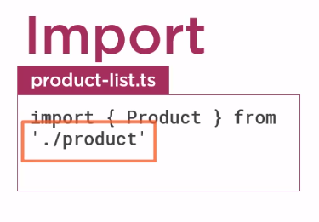

**What is Angular Module?**

Angular module help organize an application in a cohesive blocks of functionality. Every Angular application has at least one angular module. In short angular module is known as app module.

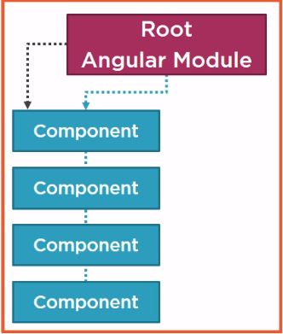

As the application get bigger and more features are added. We can group those features into their own feature module.

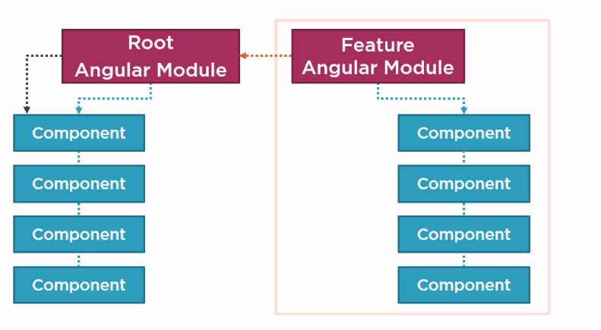

We can also define shared or common modules for code reuse by multiple angular modules. This keeps our code more organized and we can either run this module at startup or lazy load as it is needed.

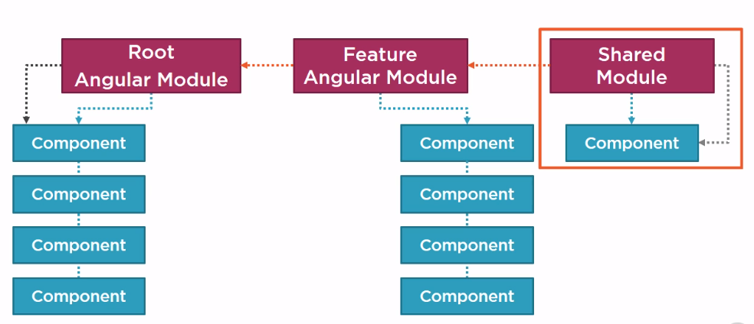

In each angular module we declare set of components and other code file associated with the module and the dependencies needed by those components. Each component belongs to only one module.

We will learn more about module later.

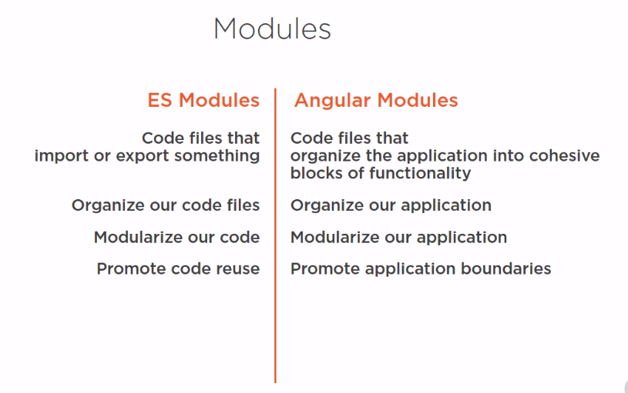

We can think of our angular application as a set of components. We create each component and then arrange them to form our application.



An Angular component includes a template. Template is use to define a view for our application. A template is created using HTML. We use angular binding and directives in the HTML to power up the view.

Angular component also included Class. Class is used to write the code associated with the view. The class is created with typescript. The class contains the properties or data elements available for the use of the view. Class also contains methods, which are the logic need by the view.

An Angular Component also included metadata. Which provides additional information about the component Metadata is defined with a decorator.

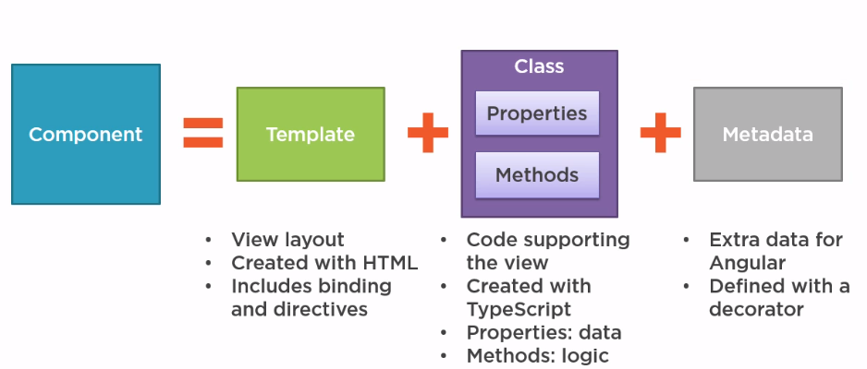

**Here is an example of a simple component:**

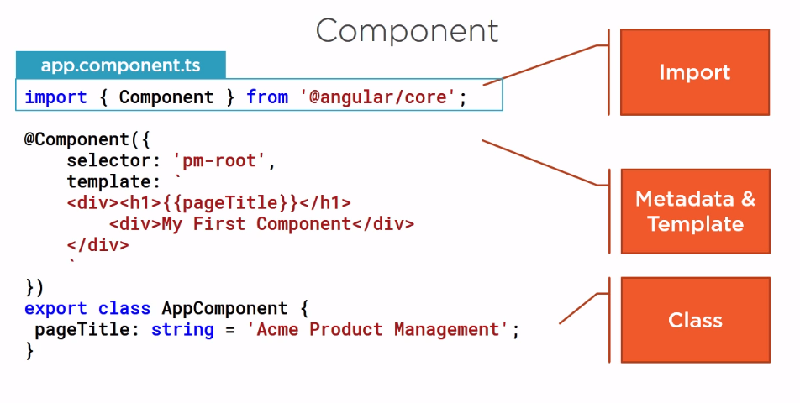

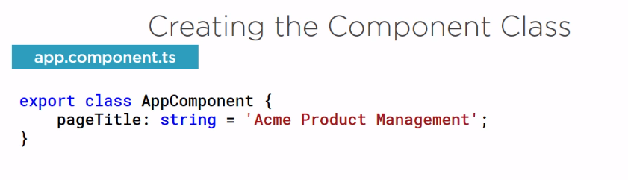

If you have experienced any object oriented language like java then this code may look familiar. A class is a collection of state/properties and behavior/methods.

A Class is defined by using the **‘class’** keyword followed by the class name. By the code convention the Class name will have a prefix as the **feature name** and followed by **‘Component’** as suffix. Also by convention the root component is called as **AppComponent**.

**export** keyword used before the class to export it so that other components of the application can use this class.

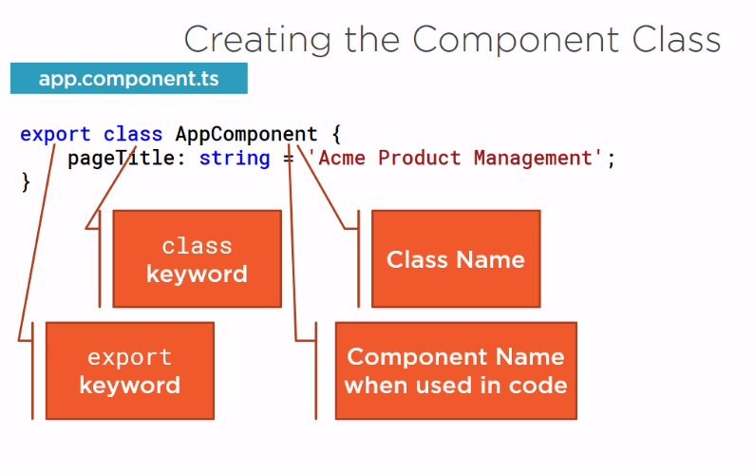

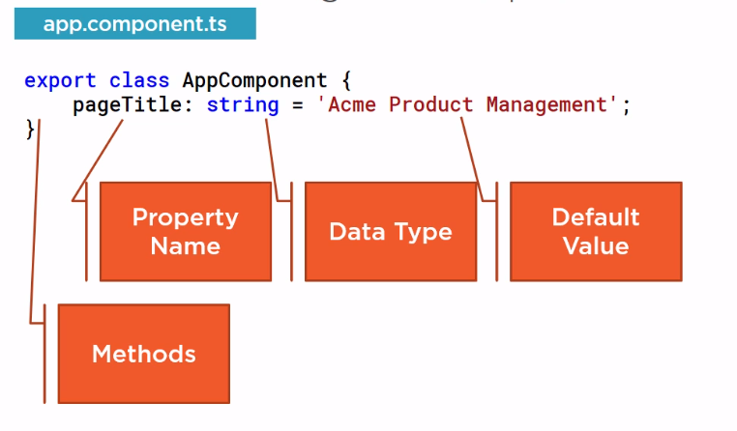

* Methods are defined inside the class body. Methods name follows camel case.

**Note:**

As we know a component is a mixture of Class, Template, and MetaData. We also need to define a template and to define a template we need metadata. Let’s understand what is a metadata.



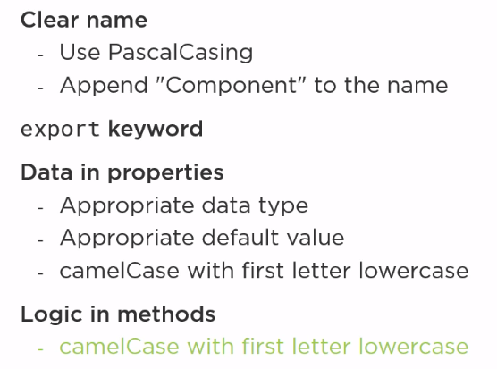



A class becomes an angular component when we give component metadata. Angular needs metadata to understand how to instantiate the component and construct the view and to interact with the component. We define a component’s metadata with **@Component** function. In Typescript we attach that function with a class as decorator.

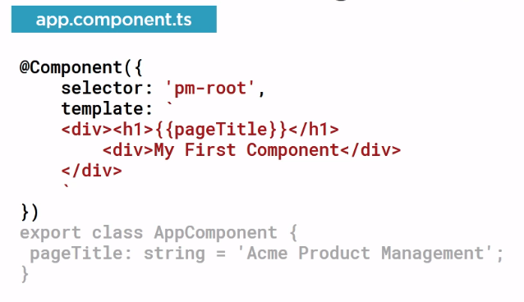

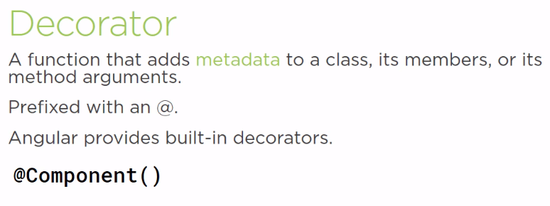

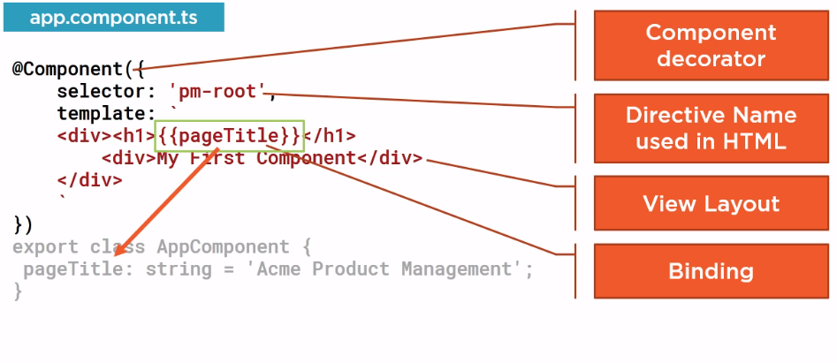



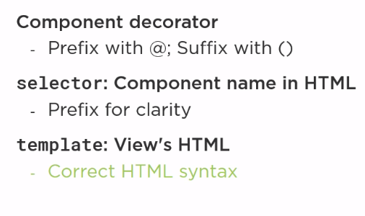



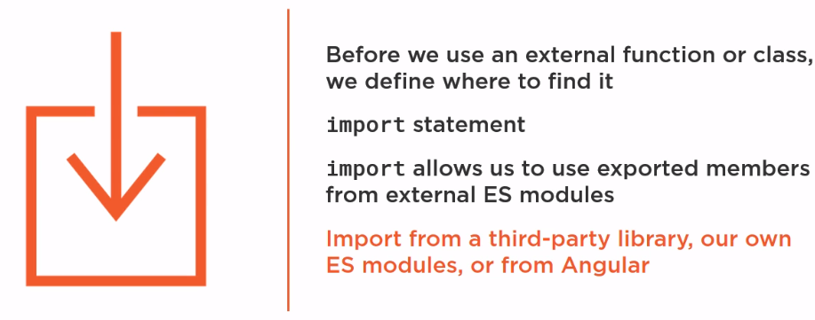



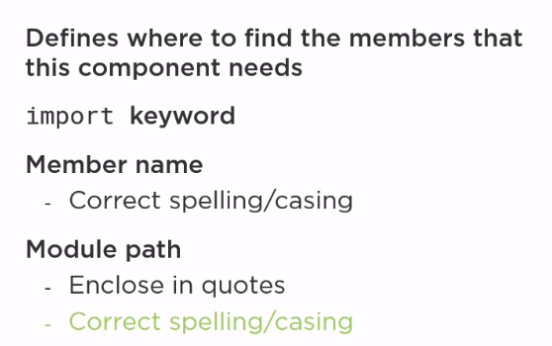

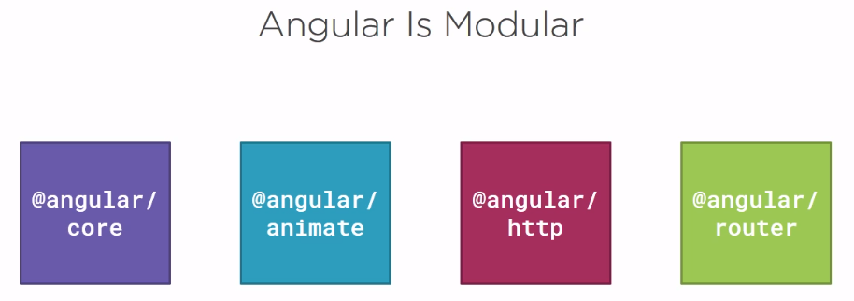

**Note:**

* Angular is modular. It’s a collection of library modules. Each library itself is a module made up of several related feature modules.
* When we need something from angular we import it from angular library modules.

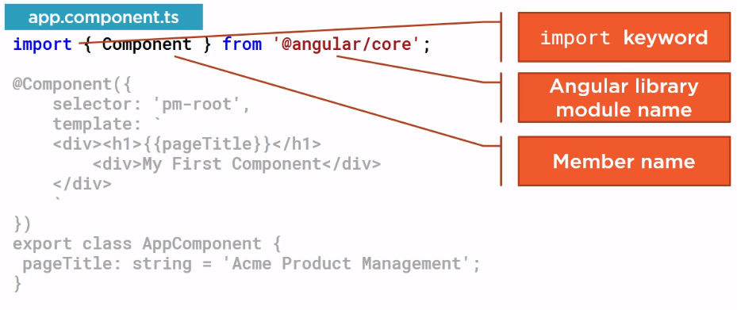

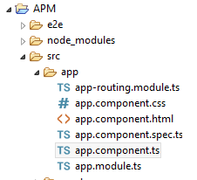

**Root App Component**

**app.component.ts**

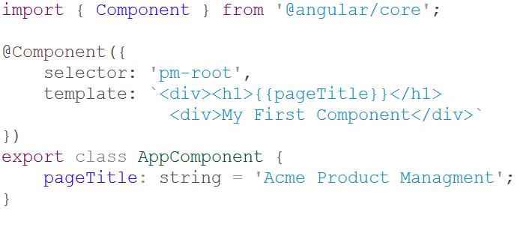

We need to tell angular to load our component through a process called bootstrapping. We first setup the index.html file to host our application. Then we define our root angular module to bootstrap out root component.

Most angular app has an index.html file that contains the main page for the app. This index.html file is often the one true page of the app. And hence an application is called Single Page Application or SPA. But it looks to the user as if there are lots of pages.

As you can see we are using the selector in the component as an HTML element in **index.html** and the template defines what we want to display in the page.

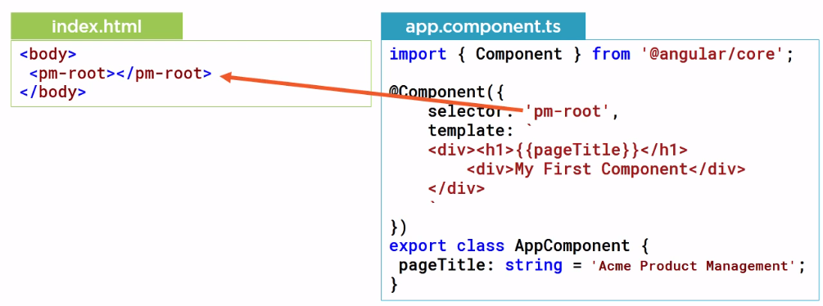

But the question is, how does the Angular compiler know about this custom HTML element?

Answer:

It looks in the angular module. Angular module helps us organize our application into cohesive set or block of functionality and provide boundaries within our application. They also provide a template resolution environment. Means, When the angular compiler sees a directive/element or html tag in a template, it looks to the Angular module for the definition so we declare AppComponent in an Angular module so the compiler can find it. We also use the module to bootstrap our startup component, which is our AppComponent and we want our application to work correctly in the browser, so we add Angular Browser module to our Angular module’s imports.

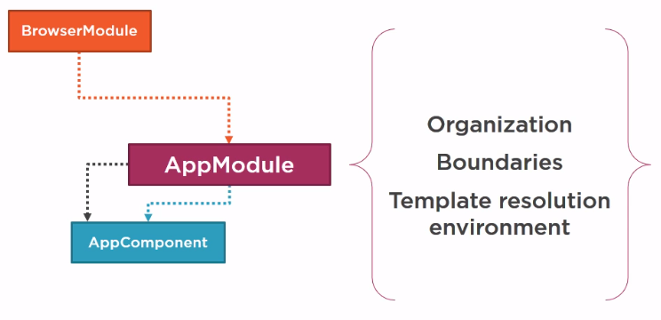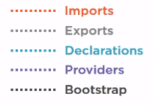

Below is our application’s root Angular module.

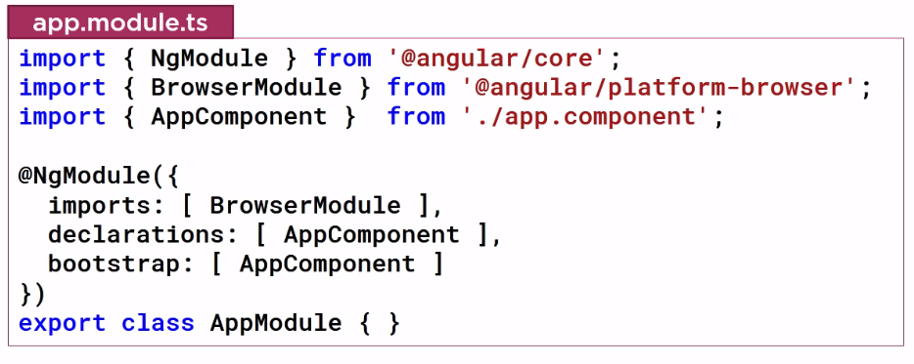

Our Application’s root Angular Module is define as a class. We identify the class as an Angular Module by attaching **@NgModule** Decorator and passing in metadata defining the details of this angular module. For the @NgModule decorator the properties are arrays. Here we have imported browser module which every browser application must import. Browser module register is important to application service provider such as error handling. The bootstrap array defines the startup component of the application, which is our AppComponent. The startup component contain the selector we use in the index.html file, which in this case it does.

**Recap**

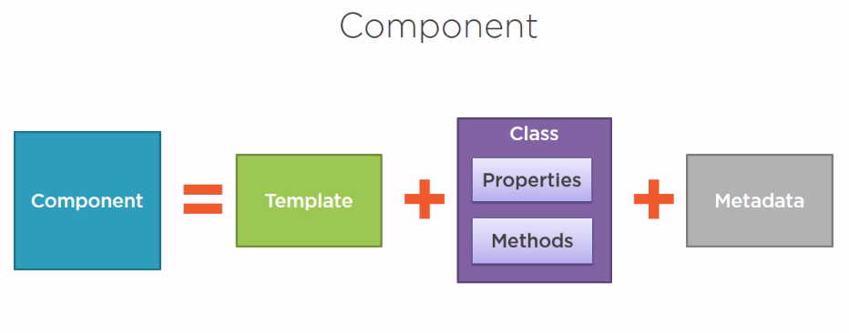

**Building a Template**

We can use the template property and define an inline template using a simple quoted string with single or double quotes. Or we can define an inline template with a multiline string by enclosing the HTML and ES2015 back ticks. The back ticks allow composing a string over several lines, making the HTML more readable. We use this techniques to build our template in the last module. There are some advantages to defining an inline template using one of these two techniques:

* The template is directly defined within the component, keeping the view and the code for that view in one file. It is than easy to match up our data binding with the class properties, such as the page title in this example.

However, there are disadvantages as well:

* When defining an HTML in a String, most development tool don’t provide intelliSense, automatic formatting, and syntax checking, especially as we define more HTML in the template. These issues become challenges.

In many cases the better option is to define a linked template with the HTML in its own file. We can then use the templateUrl property in the component metadata to define the URL of our HTML file.

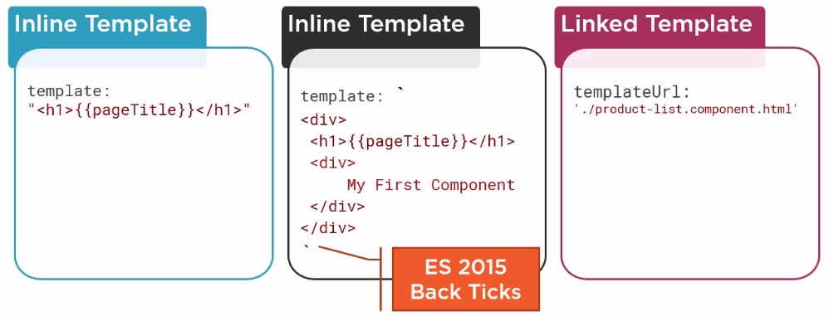

Let’s do some practical in our Angular App:

To make the page more responsive and decent, we will use bootstarp and font-awesome library.

To install these packages type:



**Note:**

Installing packages doesn’t provide access to their style sheets. For that we need to import the styles for these packages into our global application style sheets, which is the style.css file.

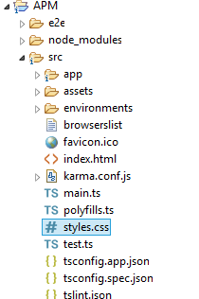

**style.css**

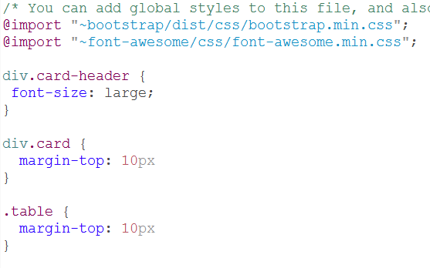

**Now, let’s add an external template file for the product list component.**

**Note:**

By convention each feature of the application has its own folder under the app folder. So, let’s add a new Folder and name it products.

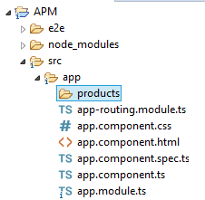

In that folder we’ll create the template for our product list component. By convention, the name of the template is the same name as the component with an HTML extension. We’ll call our product list component ‘**product-listcomponent.html**’ .

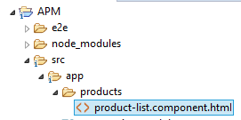

<!-- We are using Twitter

style classes -->

<div class='card'>

<div class='card-header'>

Product List

</div>

<div class='card-body'>

<div class='row'>

<div class='col-md-2'>Filter by: </div>

<div class='col-md-4'>

<input type='text'/>

</div>

</div>

<div class='row'>

<div class='row'>

<h4>Filtered By: </h4>

</div>

</div>

</div>

<div class='table-responsive'>

<table class='table'>

<thead>

<tr>

<th>

<button class='btn btn-primary'>

Show Image

</button>

</th>

<th>Product</th>

<th>Code</th>

<th>Available</th>

<th>Price</th>

<th>5 Star Rating</th>

</tr>

</thead>

<tbody>

</tbody>

</table>

</div>

</div>

**Now, Let’s build a Component in the same folder:**

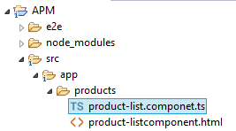

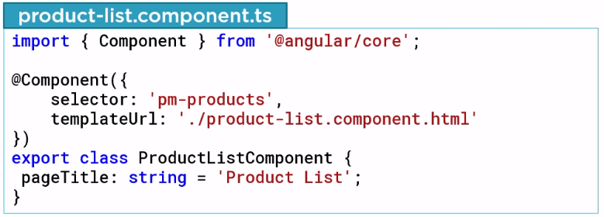



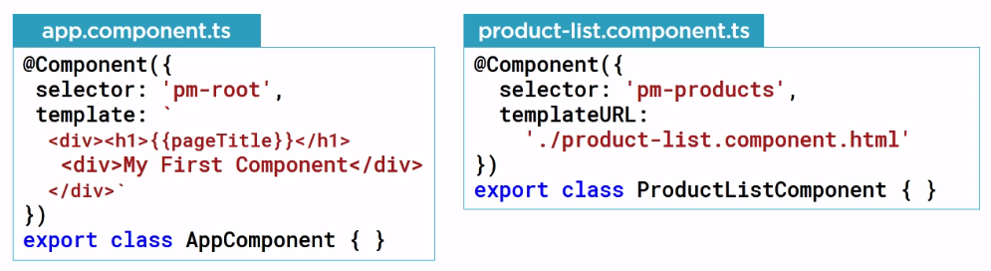

**Then**

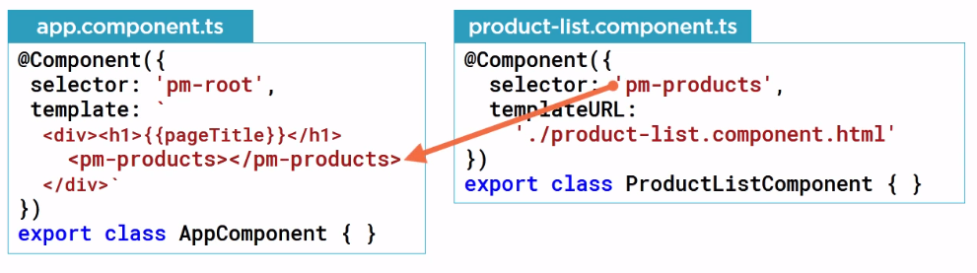

Now we need to add the component in the app module:

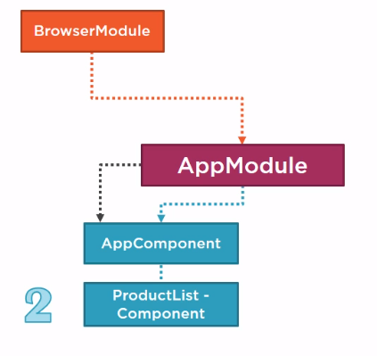

We need to add a module in app.module.ts

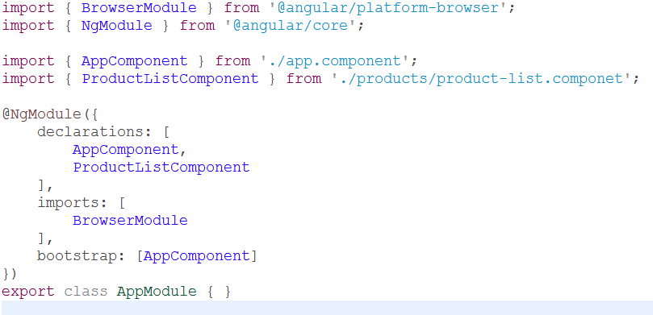





In Angular, binding coordinates communication between the components class and its template, and often involve passing data. We can provide value from the class to the template for display, and the template raises event to pass user action or user-entered value back to the class. The binding syntax is always defined in the template. Angular provides several types of binding, and we’ll look at each of them.

For now, we’ll cover interpolation.

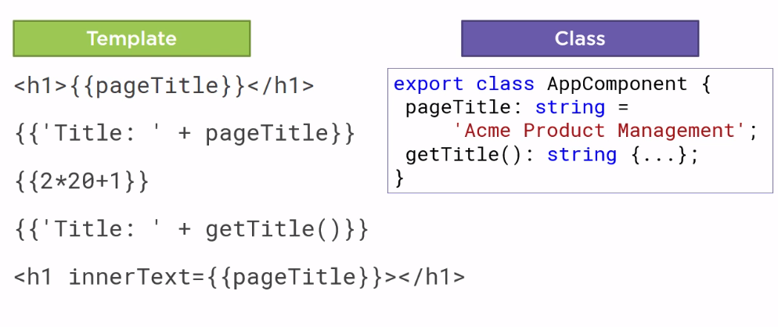

* The double curly braces that signify interpolation are easily recognized. The page title in this example is bound to a property in the component’s class.
* Interpolation is a one way binging, from class property to the template.
* We can also perform operation such as concatenation or simple calculation.

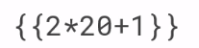or 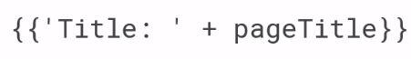

* We can ever call a class method.
* We use interpolation to insert the interpolated strings into the text between HTML elements, as shown:

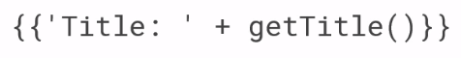

* Or, We can also do something like this:

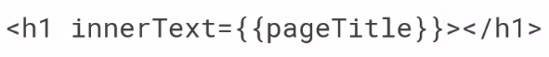

* The syntax between the interpolation curly braces is called a template expression. Angular evaluate that expression using the component as the context. So, Angular looks to the component to obtain property value or to call methods. Angular then convert the result of the template expression to a string assigns that string to an element or directive property.

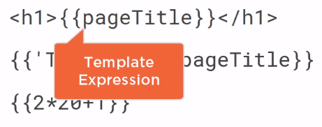

We can use interpolation like this:

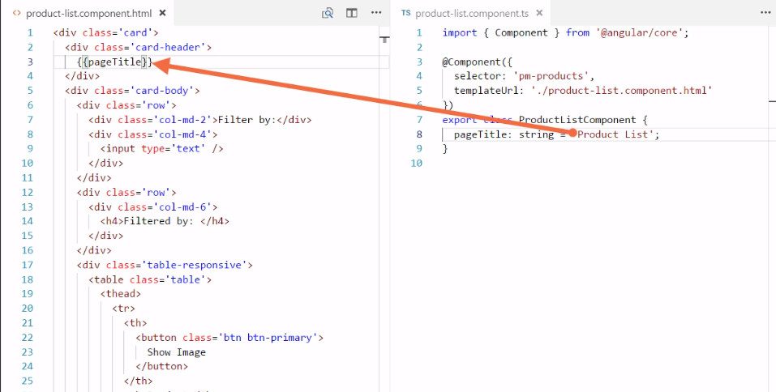



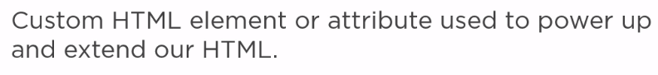

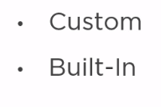

* We can build our own custom directive.
* Or, We can use Angular’s built in directives.

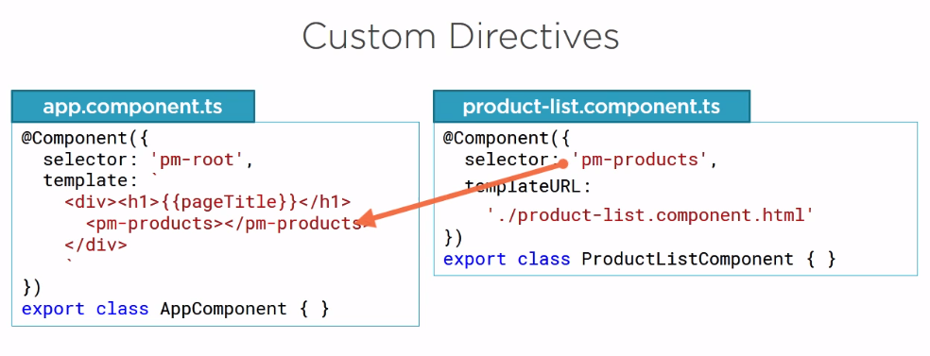

* Previously we have seen how to built a component and use it as a custom directive, we used ‘pm-products’ directive to display our product list template.

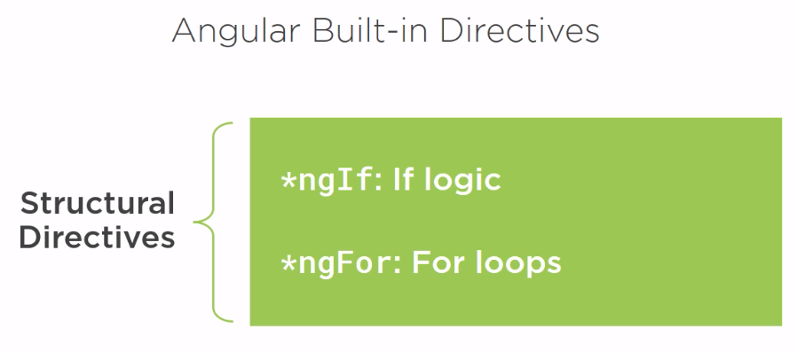

* In addition to our own custom directive, we can also use Angular’s built in directives. We’ll look at built in **structural directives**
* **A structural directive modifies the structure, or layout, of a view by adding, removing or manipulating elements and their children.**
* Structural directive power up our HTML with IF logic and FOR loops.

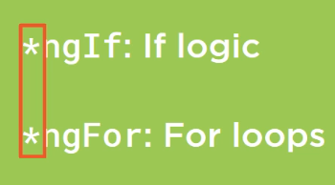

* Notice the asterisk in front of the directive name, that marks the directive a structural directive.

Let’s first look at **\*ngIf**:

Note:

*ngIf is a structural directive that removes or recreates a portion of the DOM tree based on an expression.

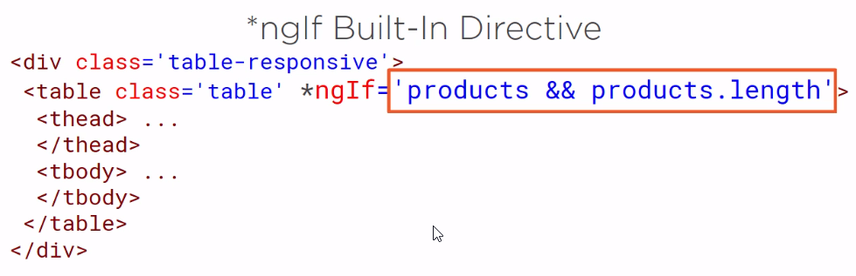

If the expression assigned to the ngif evaluates to a false value, the element and its children are removed from the DOM tree. If the expression evaluates to true value, a copy of the element and its children are reinserted into the DOM.

So, now the question is how the Angular will find these in built directive. Well, BrowserModule exposes the ngIf and ngFor directives.

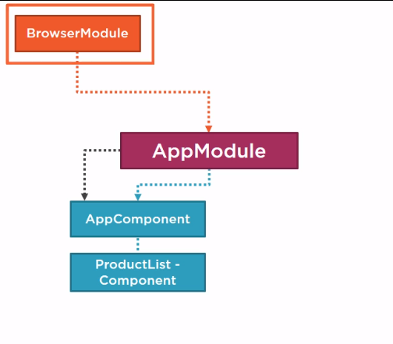

Let’s try our **ngIf** directive:

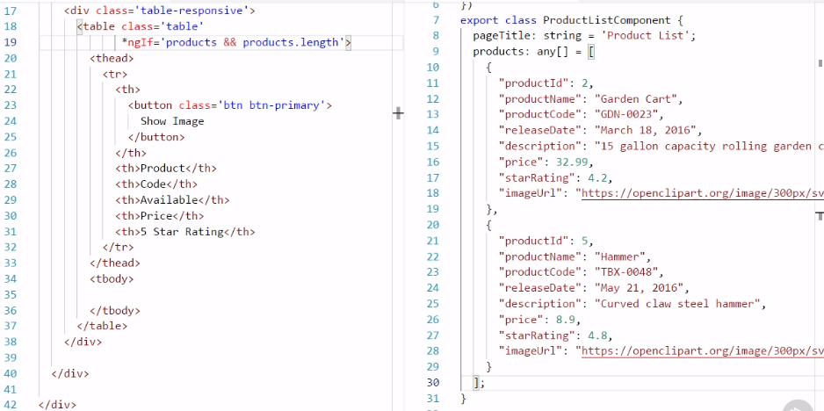



* *ngFor is another structural directive. ngFor repeats a portion of the DOM tree, once for each item in an iterable list.
* So we define a block of HTML that defines how we want to display a single item and tell Angular to use that block for displaying each item in the list. For example, we want to display each product in a row of a table. We define one table row and its child table data elements. That table row element and its children are then repeated for each product in the list of products.

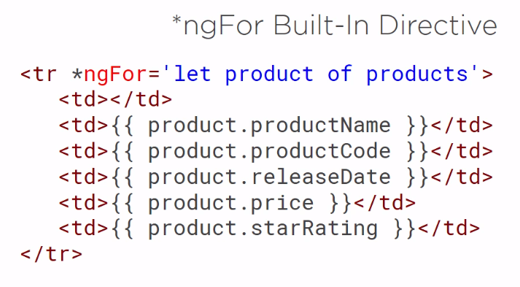

**Note:**

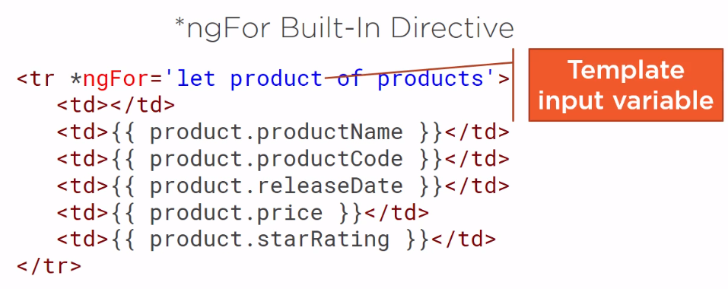

* The **let** keyword here creates a template input variable called product. We can reference this variable anywhere on this element, on any sibling element, or any child element.
* Notice the ‘ **of** ‘ instead of in here, we’ll talk more about that in a moment.

Output:

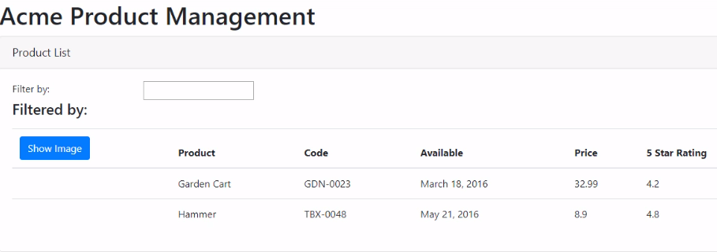

**Why this ngFor syntax has ‘**product of products**’ and not ‘**product of products**’ in products?**

The reason for this has to do with ES2015 (ES6) for loops. ES2015 has both **for of** loop and **for in** loop. The **for of** loop is similar to a **for each** style loop. It iterates over an iterable object, such as an array. For example,

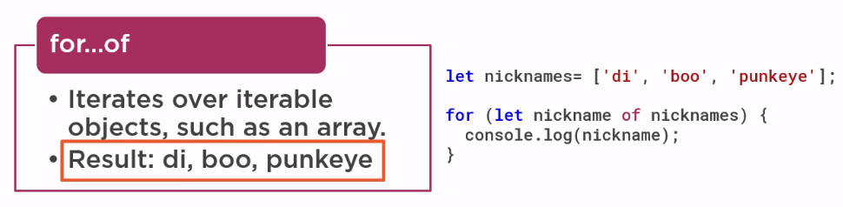

The **for in** loop iterates over the properties of an object. When working with an array, such as the below example,

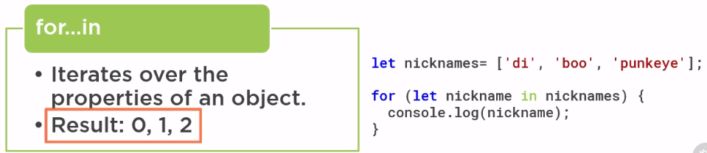

The array indexes are innumerable properties with integer names and are otherwise identical to general object properties, so we see each array index logged to the console.

Since, the ngFor directive iterates over iterable objects not their properties, Angular selected to use the of keyword in the ngFor expression.

**Summery**

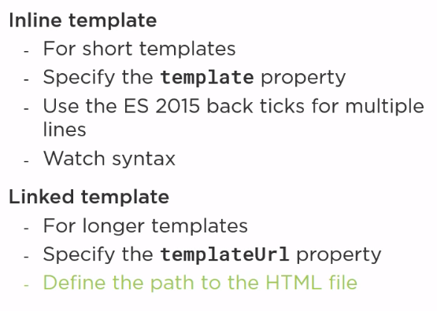

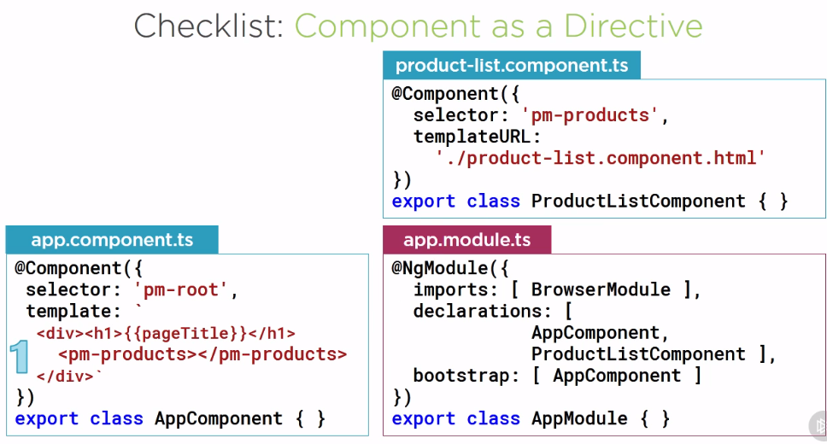

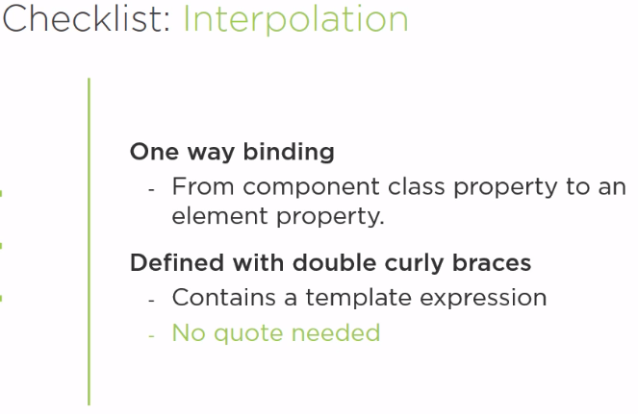

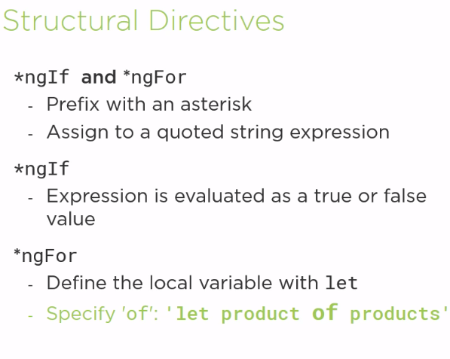



Property Binding allows us to set a property of an element to the value of a template expression. For Example,

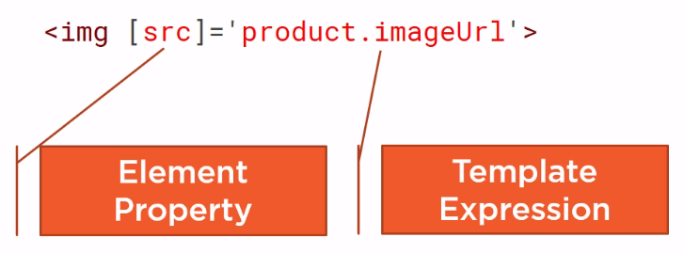

Here we bind the src property of the image element to the imageUrl property of the product, effectively defining the source of the image from information in our component class.

Note:

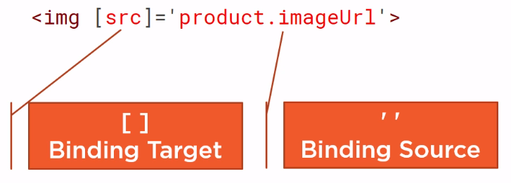

Our binding target is always enclose in square brackets and the binding source is always enclosed in quotes and specifies the template expression.

Similar to this, we can also use interpolation for doing the binding:

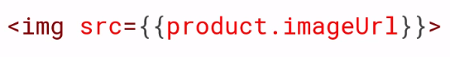



Remember:

**Property Binding and Interpolation are both one way binding.**

Let’s add some property binding to our sample application:

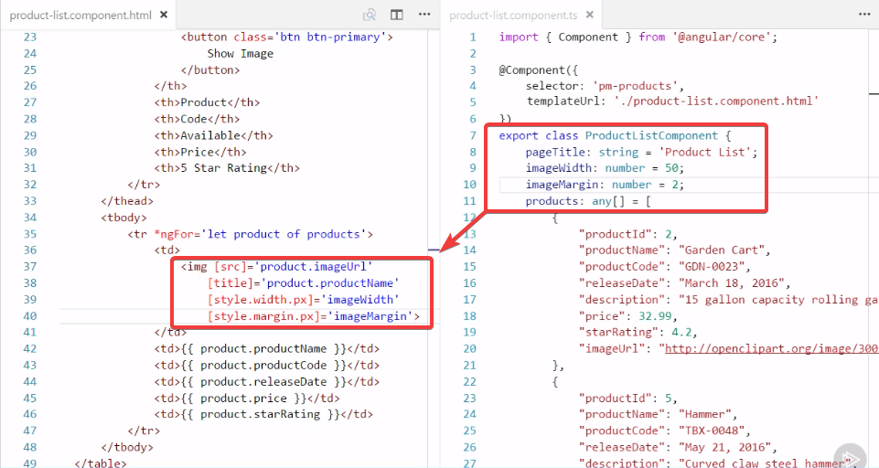

But our images are always displayed. The show image button doesn’t work yet. To hook up the button , we need to respond the user events.

So, far all of our data binding is one way from the component class property to the element property. But there are times we need to send information the other way to respond to the user events. For example, to perform an operation when the user clicks a button, a component listens for user actions using event binding as shown below:

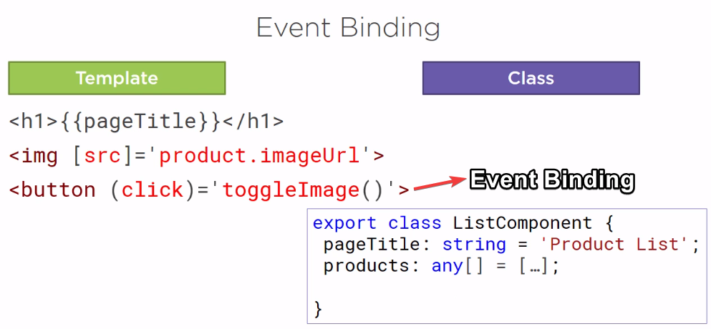

Notice: How similar the syntax is to property binding. In the example, the component listens for the click event on a button. The name of the bound event is enclosed in parenthesis, identifying it as the target event, to the right of the equals is the template statement. This is often the name of a component class method followed by open and closing parentheses and enclosed in quotes :

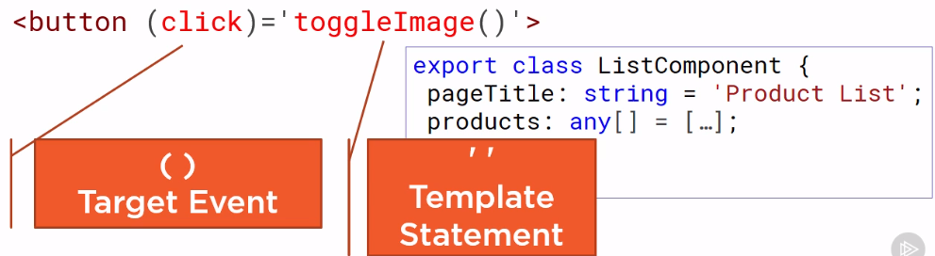

If the event occurs, it calls the specified method in the component:

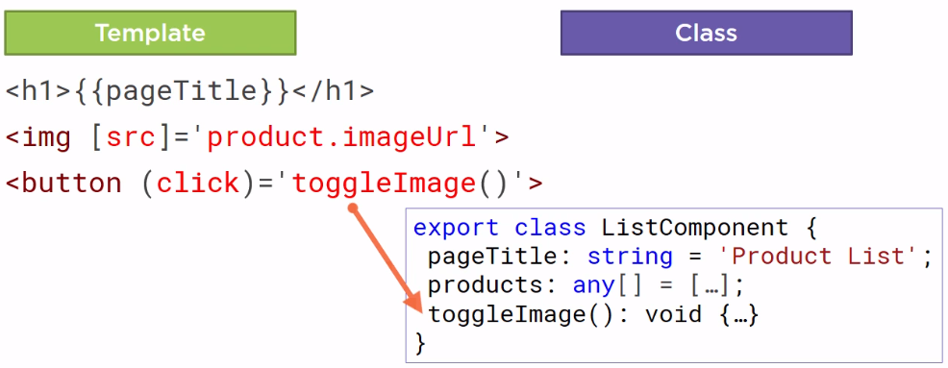

You can find the event with the documentation in the below link:

[**https://developer.mozilla.org/en-US/docs/Web/Events**](https://developer.mozilla.org/en-US/docs/Web/Events)

Let’s give event binding a try:

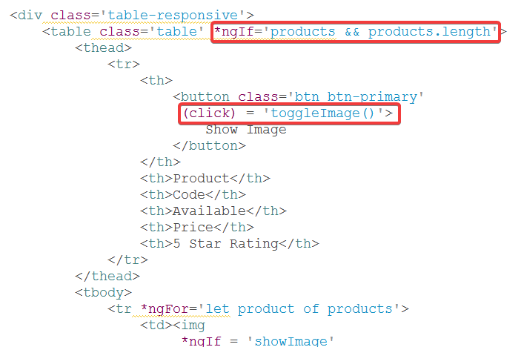

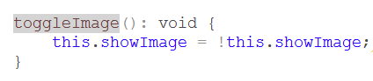

Cool! Our Image button is working

Now, let’s work with the filter box:

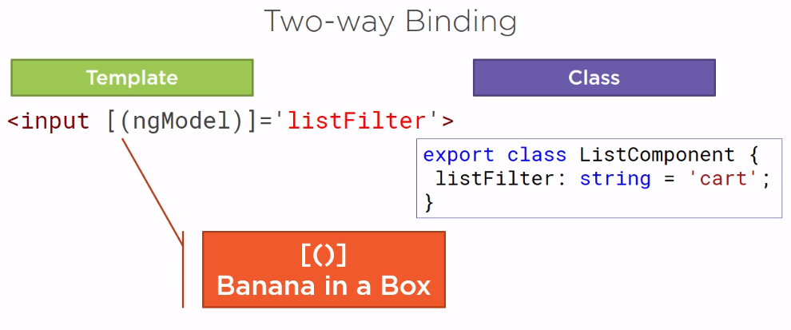

For that we need to learn two ways binding, when working with user-entry HTML elements such as input element, we often want to display a component class property in the template and update that property when the user makes a change. This process requires to way binding. To Specify two way binding in angular, we use **ngModel** directive. We enclose ngModel in square brackets to indicate property binding from the class property to the input element, and parenthesis to indicate event binding to send a notification of the user-entered data back to the class property. We assign this directive to a template expression.

To use **ngModul**, we need to import **FormsModule** in the **AppModule**:

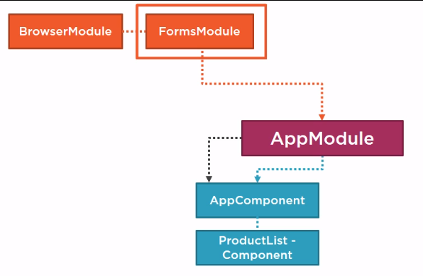

Now, let’s do some coding for implementation:

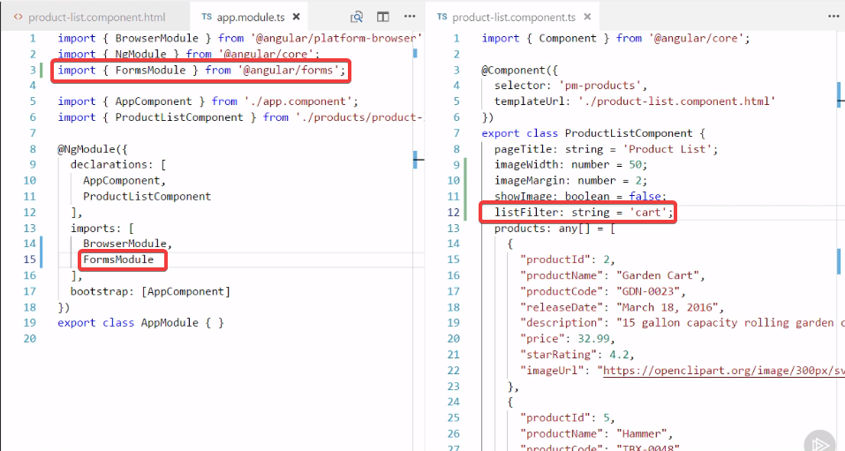

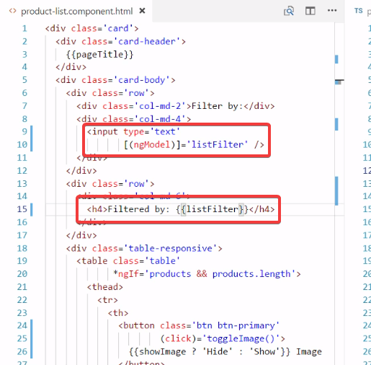

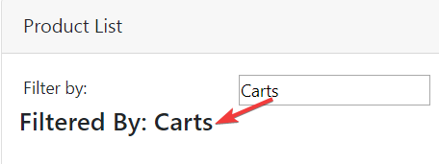

Ok, Now let’s implement the page to really filter the product based on the input.

Before doing that’s lets focus on the price column:

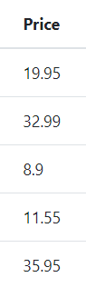

It should have a symbol for the price. For giving the proper data format. We need to learn how to work with Pipes.



Sometimes the data is not in an appropriate format for display. That’s where pipes come in handy. Pipes transform bound properties before they are displayed, so we can alter the property values to make them more user friendly or more locale-appropriate.

Angular provide some built-in pipes for formatting values, such as date, number, decimal, percent, currency, uppercase, lowercase, and so on. Angular also provide a few pipes for working with objects, such as the json pipe to display the content of an object as a json string. Which is helpful when debugging, and a slice pipe, which selects a specific subset of element from a list.

We can also build our own custom pipes.

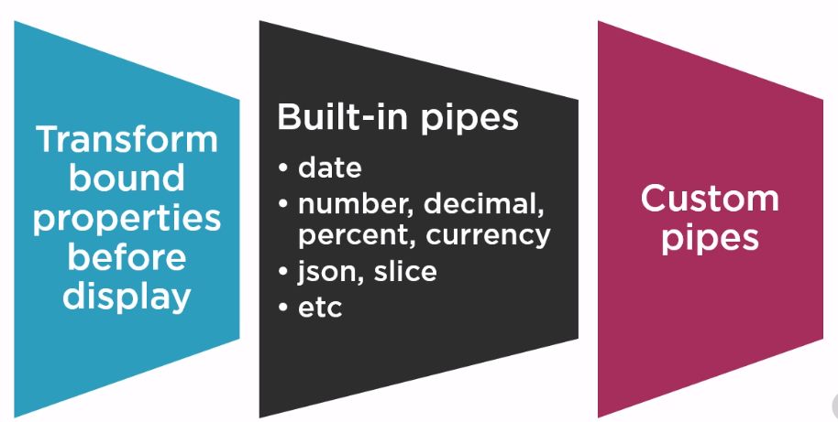

Let’s start with a simple example:

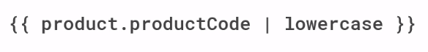

Say we want to display the product code in lower case. We can add the pipe character after the property in the template expression, and then specify the lowercase pipe. The product code is then transformed into lowercase before it is displayed.

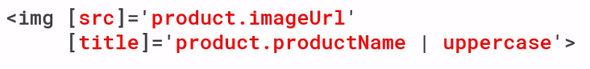

We can also use pipes in property bindings. Add the pipe after the property in the template expression and specify the desired pipe. In this example, we specified the uppercase pipe, so the image title will appear in all caps.

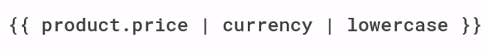

If needed, we can chain pipes. In the above examples, the price is transformed into a currency. By default, the currency pipe adds all caps, three-letter abbreviation of the local currency to the amount. If we want to display that abbreviation in lower case, we can transform it again by simply adding another pipe.



Some pipe support parameters. Parameters are defined by specifying a colon and the parameter value. For example the currency pipe has three parameters: the desired currency code, a string defining how to show the currency symbol, and digit info. The digit info consists of the minimum number of integer digits, the minimum number of fractional digits, and the maximum number. The value above of 1.2-2 means that at least 1 digit to the left of the decimal, and at least 2 digits to the right of the decimal, and no more than 2 digits to the right of the decimal, effectively defining 2 decimal palces.

Let’s do a demo:



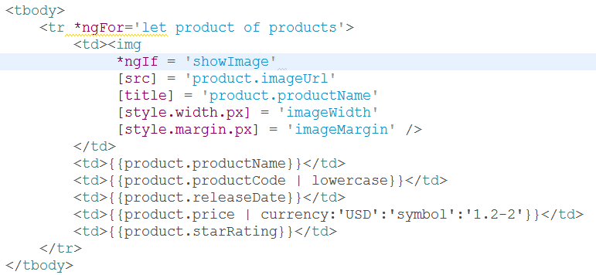

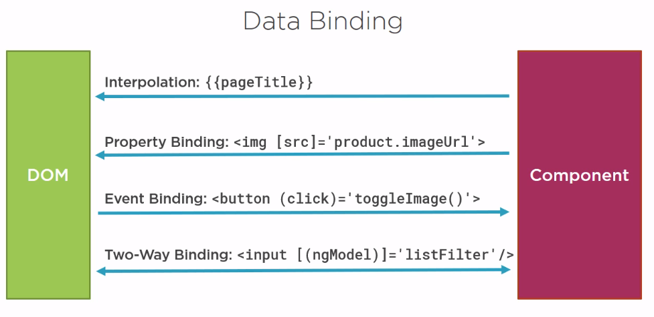

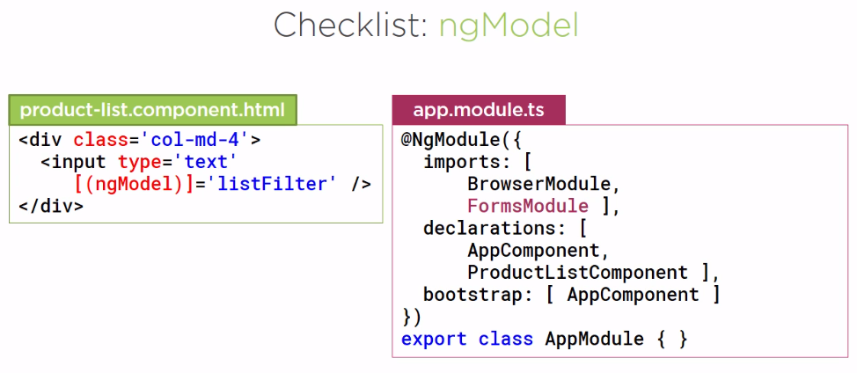



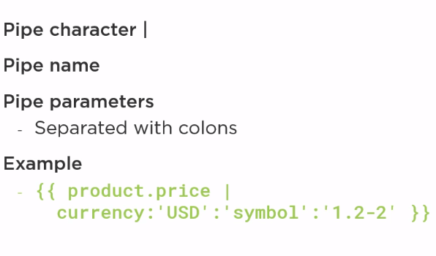

**More on components**

Components are the building block of our application. The cleaner, Stronger, and more durable we build these blocks, the better our application.

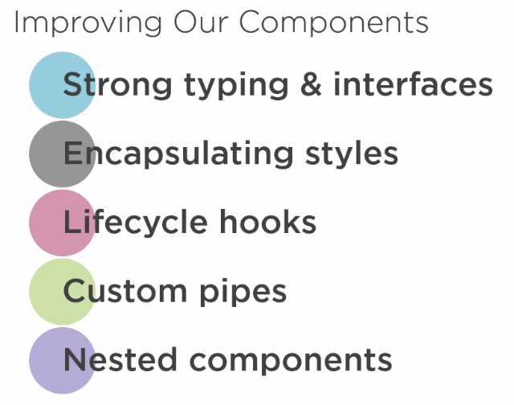

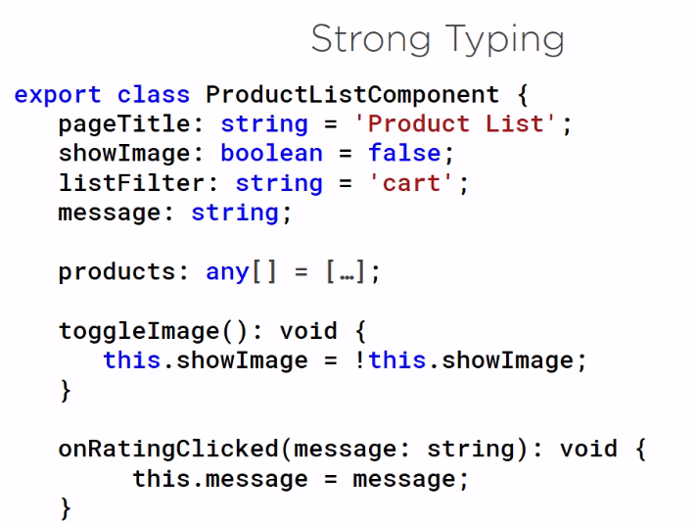

One of the benefits of using typescript is its strong typing. Every property has a an every method has a return type and every method parameter has a type. The strong typing helps minimize errors through better syntax checking and tooling.

**Note:**

In some cases, however, we have a property or method that does not have a predefined type:

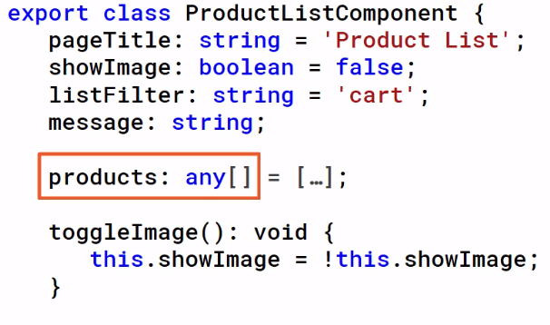

Such as our ‘products array’. We defined our products array as any, which negates the benefits of strong typing. To specify custom types, we can define an interface.

Remember:

ES5 and ES6 (ES 2015) Doesn’t support interfaces, but TypeScript does, so interfaces are transpiled out and are not found in the resulting JS. Interfaces are used for Strong Typing, ease of debugging and maintenance.

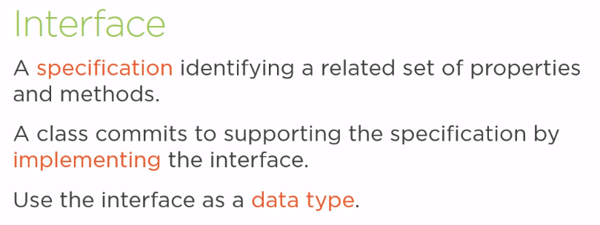

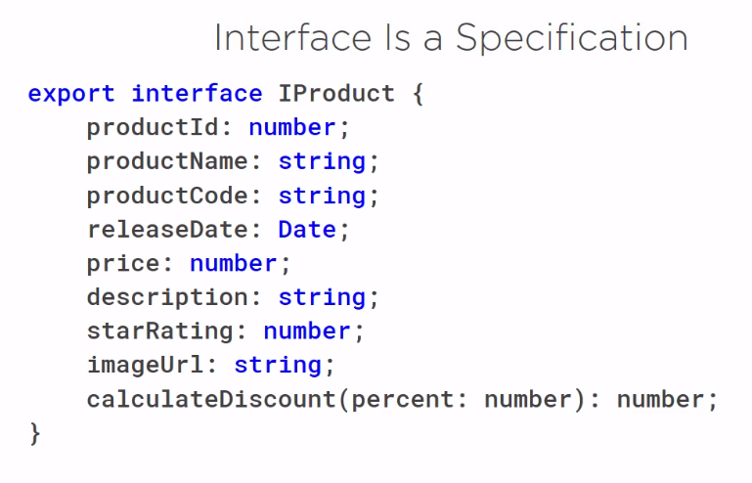

* We defined the interface using the interface keyword, followed by the interface name.
* By many naming conventions, the interface is prefixed with an ‘I’ for interface. Though, some typescript developers leave off this prefix.
* The export keyword at the front export this interface to the whole application. The bodies of the Interface contain properties and methods.
* For each property the interface included the property name, a colon, and the property data type.
* For each method, the interface includes the method name, the list of parameters along with their data types, a colon and the method return type.

To use the interface as a data types, we import

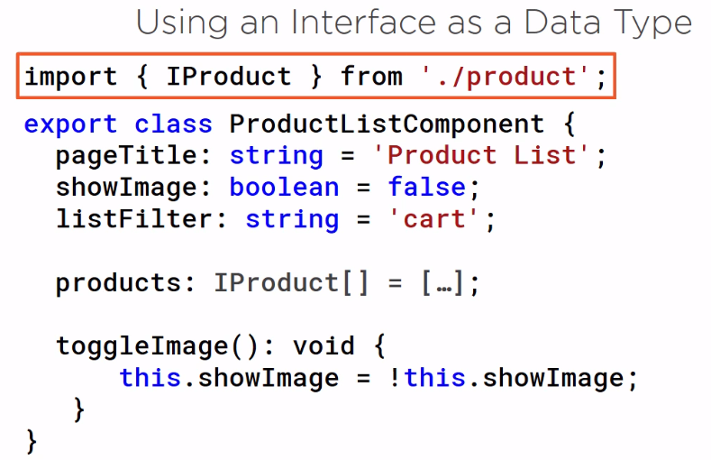

Then we use the interface name as the data type.

Let’s try our example:

1. Create ‘ **product.ts** ‘ file.

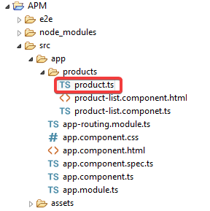

1. Write the interface:

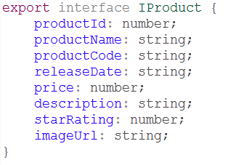

1. Import and use it in ;**product-list.components.ts’:**

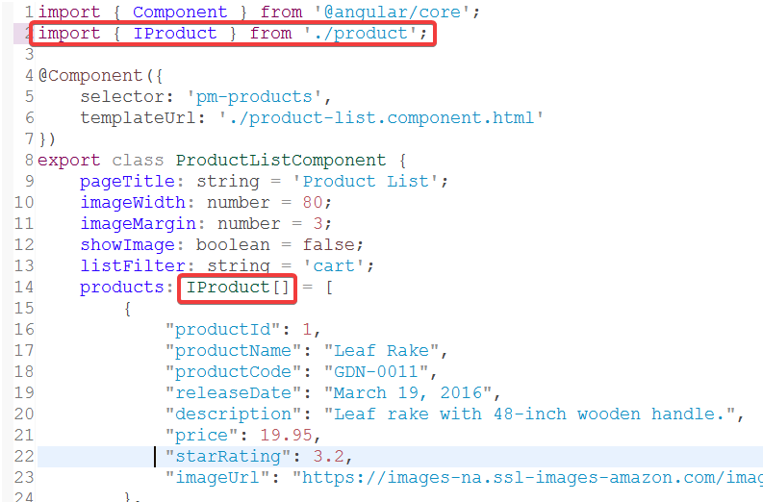



When we build a template for a component, we sometimes need styles unique to template. For example, if we build a sidebar navigation component, we may want special <li> or <div> element styles. When we nest a component that requires special styles within a container component, we need a way to bring in those unique styles. One option is to define those styles directly in the template’s HTML, but that makes it harder to see, reuse, and maintain those styles. Another option is to define the styles in an external style sheet that makes them easier to maintain, but that puts a burden in the container component to ensure the external style sheet is linked in the index.html that makes our nested component somewhat more difficult to reuse, but there is a better way.

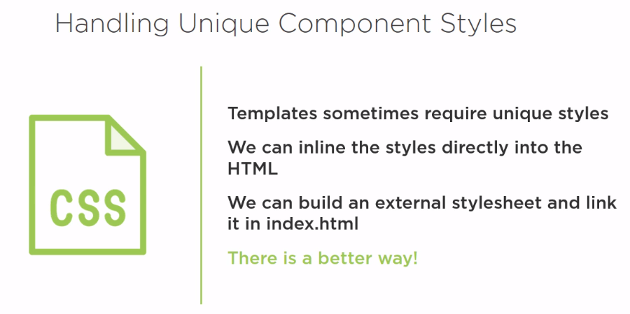

But, then there is a better way:



The component decorators have properties to encapsulate styles as a part of the component definition. These properties are styles and styleURLs. We add Unique styles directly to the component using the styles property. This property is in an array, so we can add multiple styles separated by commas. Below is an example:

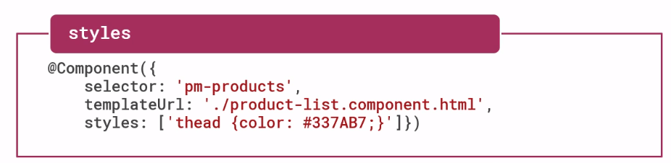

A better solution is to create one or more external style sheets and identify them with the styleUrls property. This property is an array, so we can add multiple style sheets separated by commas. By encapsulating the styles within the component, any defined selector or style are only applicable to the component’s template and won’t leak out into any other part of the application. See the example below:

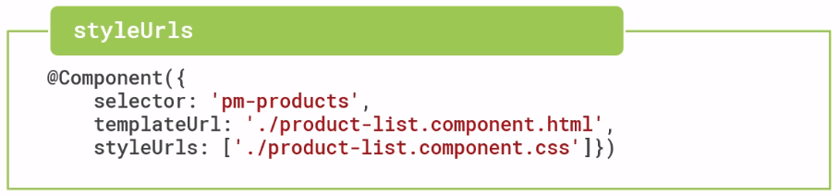

Let’s try this example:

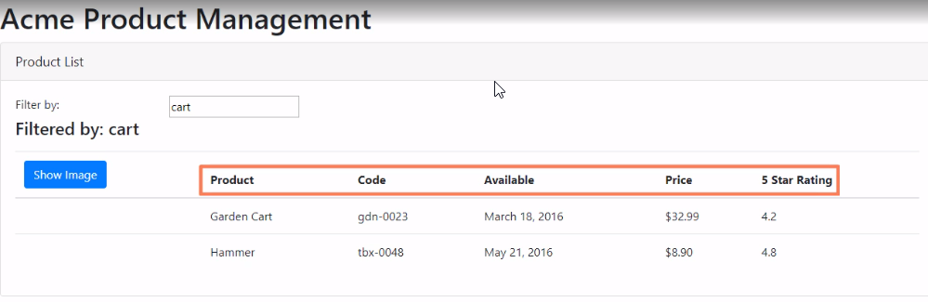

We can add some color for the table head. We will add a new file in the product folder:

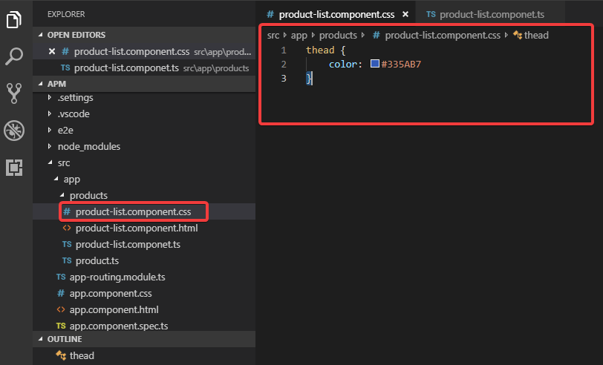

We’ll add a file by name: **product-list.component.css** and add some css code.

* To use the new sytlesheet we need add some code in the **product-list.components.ts**:

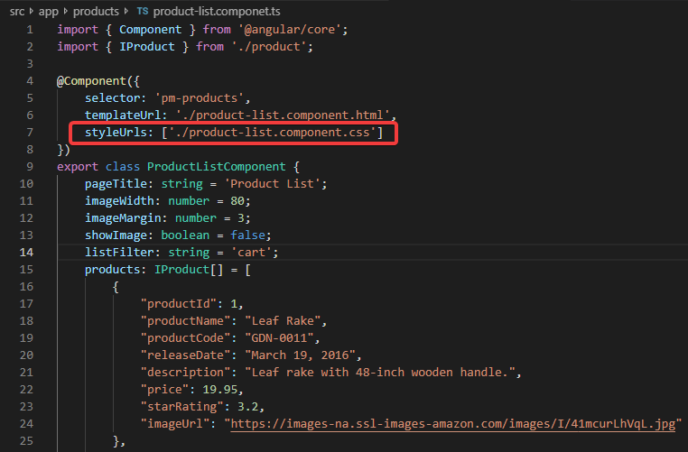



A component has a lifecycle managed by Angular:

1. Angular creates a component.
2. Renders it
3. Creates and Render its children
4. Processes changes when its data bound properties change.
5. Then Destroys it before removing its template from the DOM.

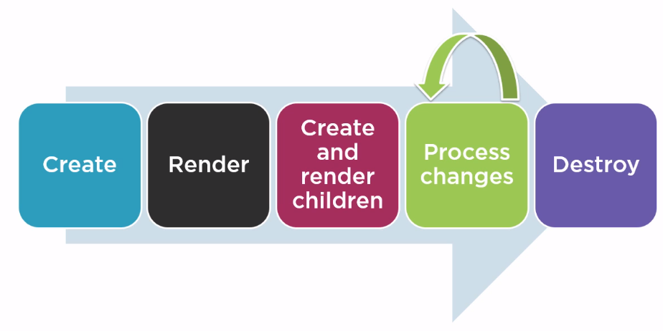

Angular provides a set of lifecycle hooks we can use to tap into this lifecycle and perform operations as needed.

We’ll limit our focus to the three most commonly used lifecycle hooks.

* Use the **onInit** lifecycle hook to perform any component initialization after Angular has initialized the data bound properties. (This is a good place to retrieve the data for the template from a back-end service, We’ll see it later in the course)
* Use the **onChanges** lifecycle hook to perform any action after Angular sets data bound input properties. We have not yet covered input properties; we’ll see those in the next module.
* Use the **onDestroy** lifecycle hook to perform any cleanup before Angular destroys the component.

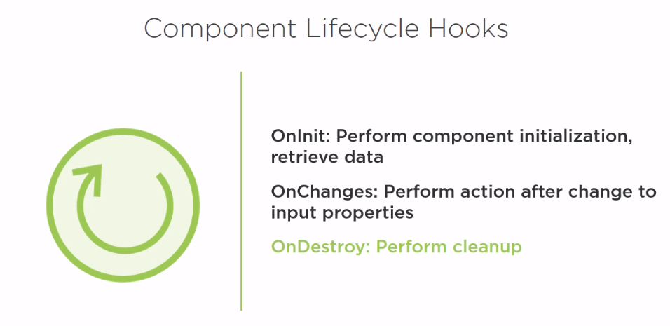

To use the lifecycle hook:

* We implement the lifecycle hook interface. Angular provides several interfaces we can implement, including one interface for each lifecycle hook.
* We need to import the lifecycle hook interface:
* We can then write the hook method. Each lifecycle interface define one method whose name is interface name prefixed with **ng**.

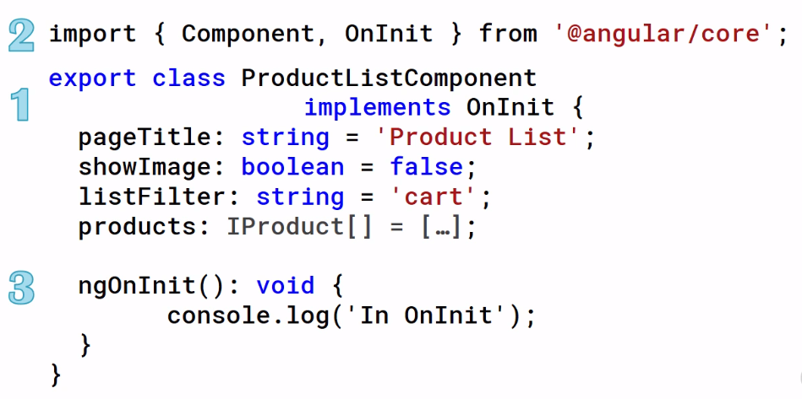

We’ll work more on lifecycle hooks later.



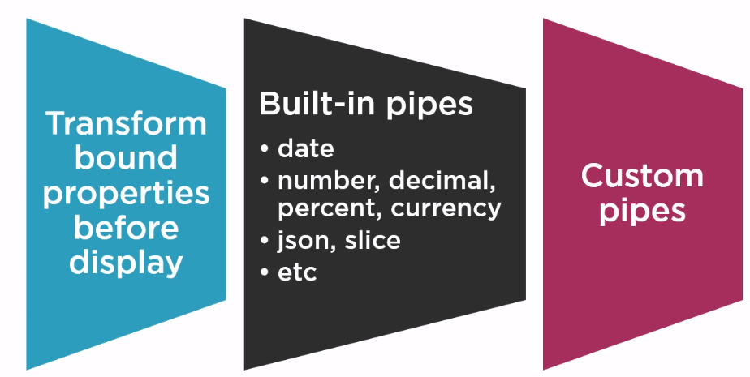

In this module we will learn how to make custom pipes. For our sample application, the Code Column is stored with a dash, and displayed that way here, but the users would prefer to see the product code with a space instead.

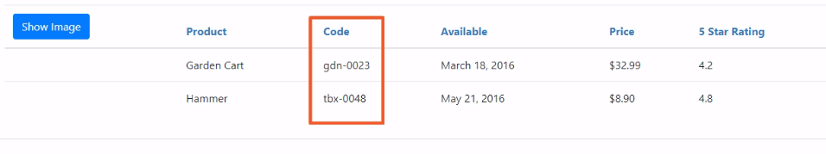

We could build a custom pipe to replace the dashes with spaces, but let’s build a more generalized pipe that transforms any specified character in a string to a space.

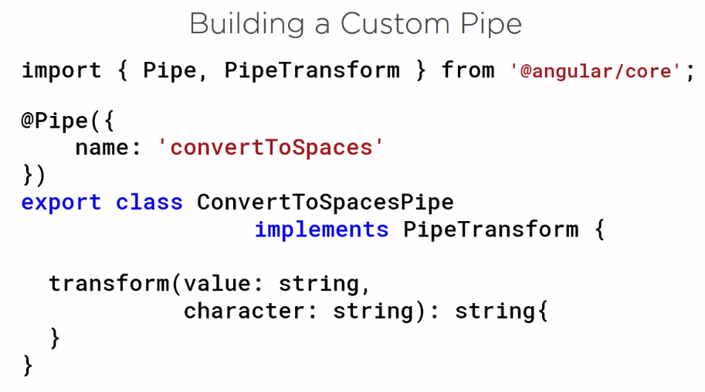

* There is a class by name **ConvertToSpacesPipe**.
* We add a pipe decorator to the class to define it as a pipe. Similar to the other decorators we’ve used; this is a function, so we add parentheses. We pass an object to the function, specifying the name of the pipe. This is the name for the pipe used in the template, as we’ll see shortly.
* We implement the interface by name **PipeTransform**, which has one method, **transform**. We write code in the transform method to transform a value and return it. The first parameter of this transform method is the value we are transforming. In the above example, we transform a string. Any additional parameters define arguments. We can use to perform the transformation. In our case, we want to pass in the character that we want to replace with spaces.
* The method return type is also defined as a string because we are returning the transform string, and of course we have our import



1. We first build a class
2. We use the @Pipe decorator
3. Our class implements PipeTransform interface
4. PipeTransform interface has one method called **transform(value:string, character:string): string.**

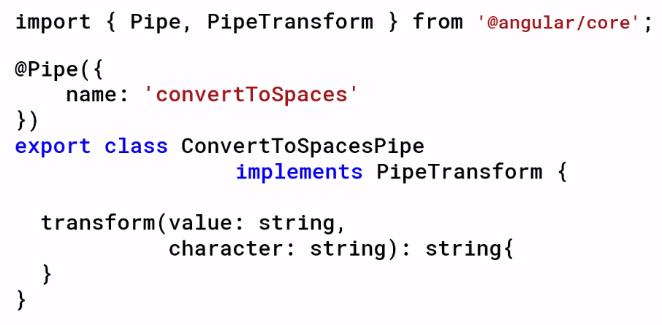

We write the code in the transform method to transform a value and return it. The first parameter of the method is the value we are transforming; in this example we transform a string. Any additional parameter defines the argument we can use to perform the transformation. In our case we want to pass the character that we want to replace with spaces. The method return type is also defined as string because we are returning the transform string

And of course we have our import statement to import what we need. Notice how similar this looks like to the components we’ve created in this course? Angular provide a very consistent coding experience .



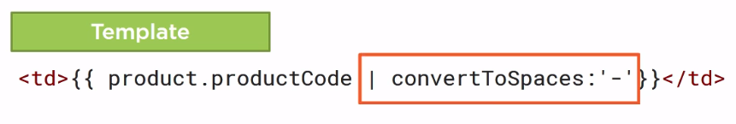

To use a custom pipe in a template, simply add a pipe and the pipe name. Include any arguments required by the transformation, separated by colons.

The value being converted, our productCode here, is passed in as the first argument to the transform method.

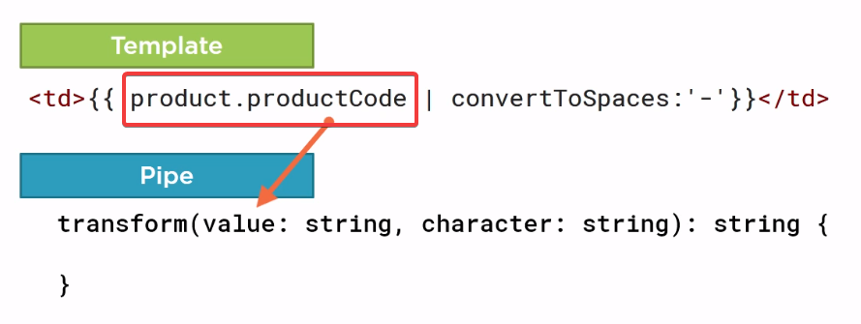

This is our pipe name:

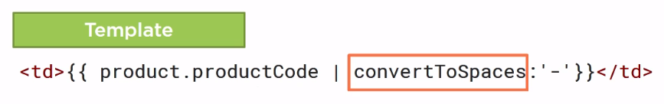

The colon identifies the pipe parameter

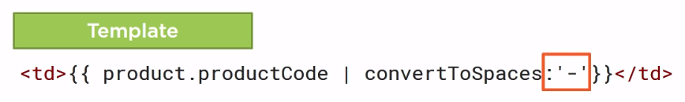

So our dash is passed in as the second argument to the transform method.

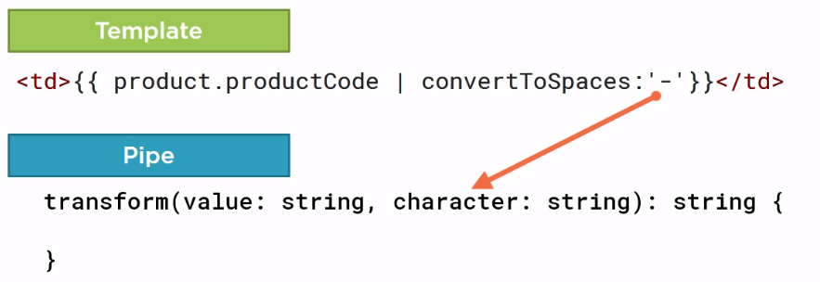

The passed in value is then transformed as defined by the logic within the method and the transformed string is returned and displayed.

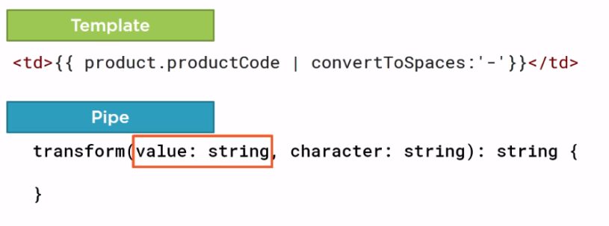

But of course that is not enough. We also need to tell Angular where to find this pipe. We add the pipe to an Angular module ( we will add in AppModule ) . But if we had multiple modules we’d add it to the module that declares the component that needs the pipe. In our example the product list component’s template needs the pipe, so we add the declaration to the same Angular Module that declares the product list component.

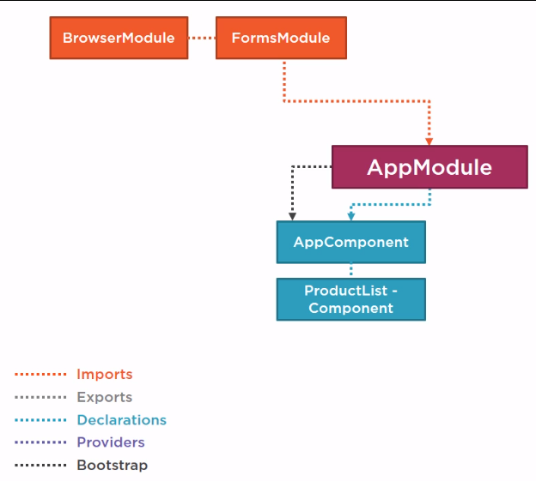

We define the pipe in the declaration array of the NgModule decorator. Now let’s build our custom pipe

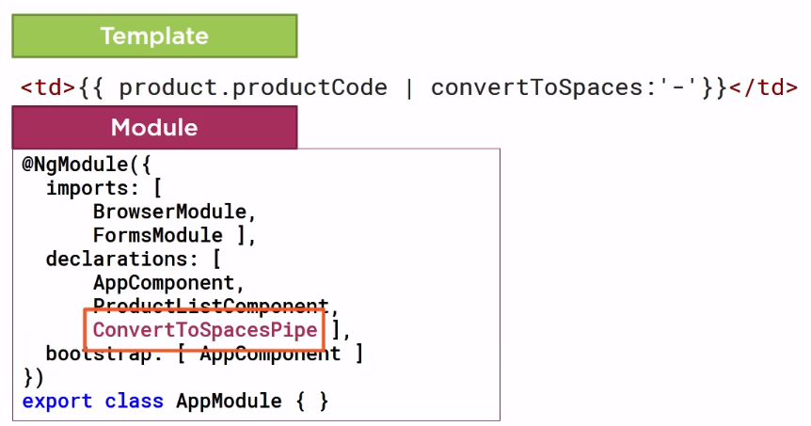

Our requirement is to transform a string so that any dashes on the string are instead displayed as spaces, but we are going to build a more generic pipe that can replace any specified characters with a space. Since our custom pipe is somewhat general, we’ll add it to the shared folder.

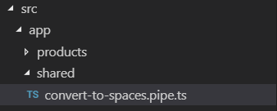

Inside the shared folder. We’ll create a new file and call it **convert-to-spaces.pipe.ts**. Following our naming convention.

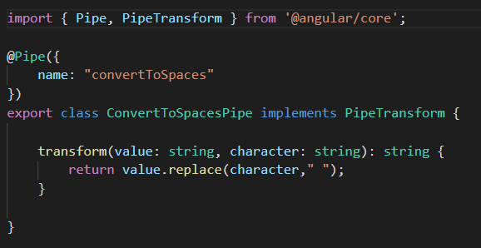

Now, we need to tell angular about our pipe:

We do that by declaring a pipe in an Angular Module to use the ConvertToSpaces pipe, so we open the angular module that declare the product list component, which in our example is the **AppModule**.

We then add **ConvertToSpacesPipe** to the declarations and add the needed import.

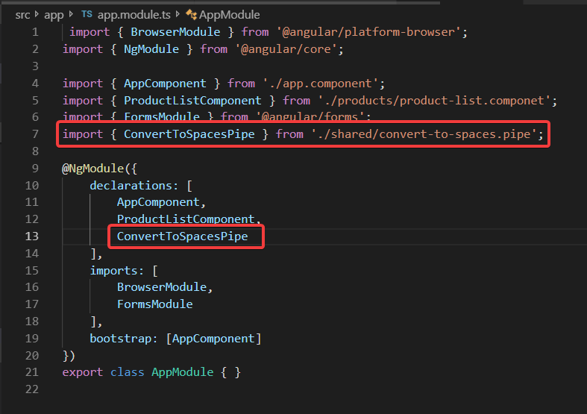

Now any component declared in **AppModule** can use the **converToSpaces** pipe.

Now we need to edit **product-list.component.html** :

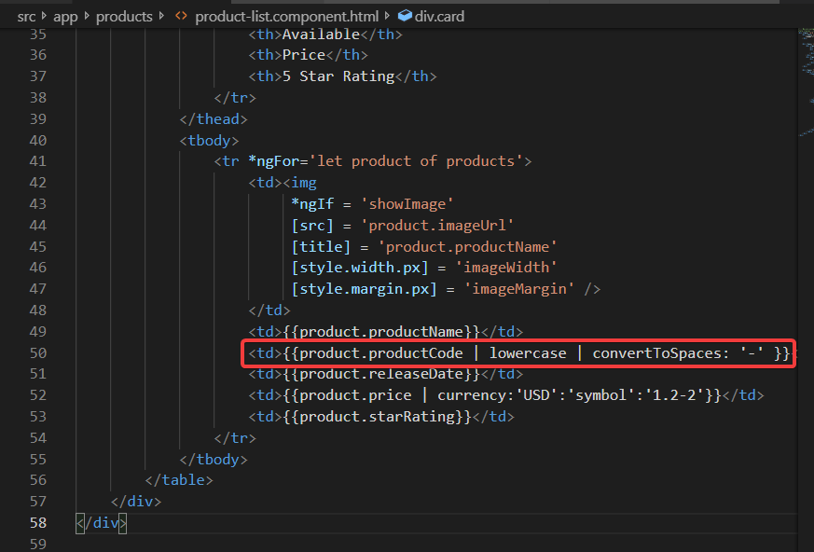

Notice, however that our page interactivity is still not complete. The Product List is not yet filtering based on the user-entered filter criteria. Let’s look at that next

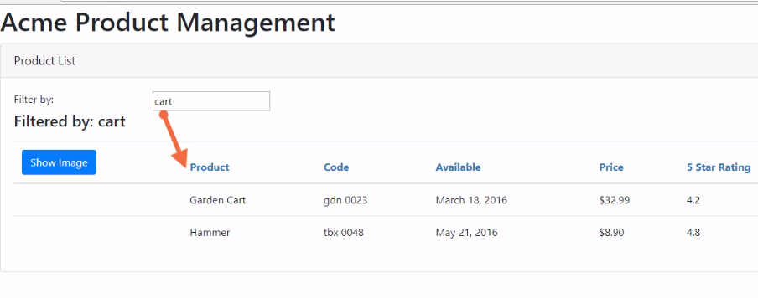

We have an input box here for the user to enter a filtered string. The list of product should be filtered on the entered string. How do we do that?

One way we can filter our list of products is to use a pipe, however, Angular doesn’t come with a built-in pipe to provide filtering or sorting.



If we have small amount of data that we are filtering or sorting, we could build a custom pipe anyway, but is there a better way:

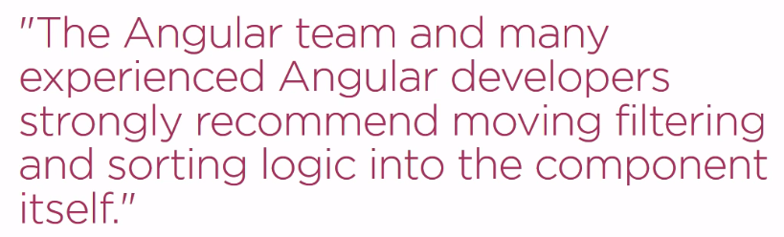

Okay let’s do that. But, How?

Here is our productList component:

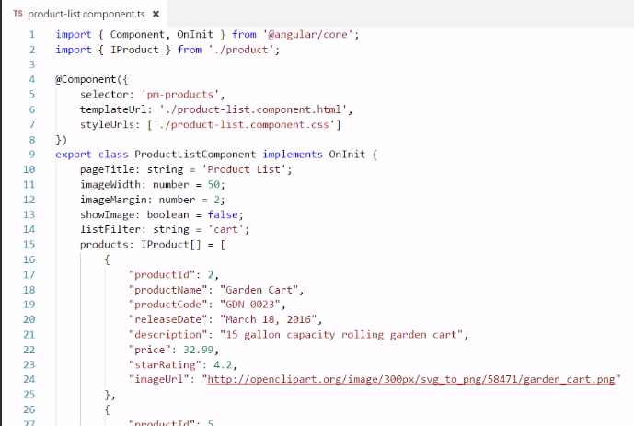

Let’s think what we need to do:

* First, we need a filtered list of products that we can bind to. We can define a property for that here. Why don’t we just filter our products array? Because once we filter our product array, we lose our original data and can’t get it back without re-getting the data from its source. Next, we need a way to know when the user changes the filter criteria.
* We could use event binding and watch for key presses or value changes, but an Easier way is to change our listFilter property into a getter and setter, like this:

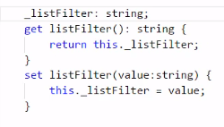

* The property getter and setter work just like the simple property. When the data binding needs the value, it will call the getter and get the value. Every time the user modifies the value, the data binding calls the setter passing in that changed value.
* If we want to perform some logic every time the value has changed, we can add it in the setter.

We want to set our filtered products array to filtered list of product, like this:

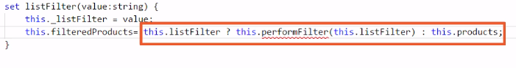

Here we are using the Javascript conditional operator to handle the possibility that the listFilter String is empty, null or undefined. If there is a listFilter value, the code filters on that value. If the listFilter is not set, the filtered products property is assigned to the entire set of products, and that makes sense. If there is no filter, we should display all of the products. But we skipped the messy part. What about this performFilter() method?

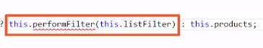

Let’s talk through it:

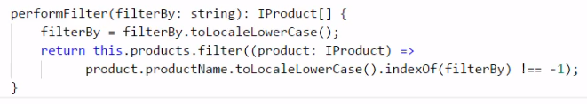

This code starts by converting the filter criteria to lowercase. Why? So we can compare Apples to apples when we filter the product list. We want case insensitive comparison. Then we returned the filtered list of products. Let’s take a closer look at he filter method call

We are using the array’s filter method to create new array with elements that pass the test defined in the provided function. We use the ES2015 arrow syntax to define that filter function.

For each product in the list, the product name is converted to lowercase and indexOf is used to determine if the filter text is found in the product name. If so, the element is added to the filtered list. See the MDN entry for filter() method in array for more information.

There is few things left out:

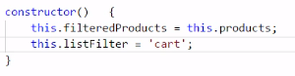

We want to set default values for both the filteredProduct and the listFilter properties. The best place to set default values for more complex properties is in the class constructor. The class constructor is a function that is executed when the component is first initialized. We want to set the filteredProducts to the full list of products, and the default listFilter to cart, like we had earlier.

Our last step then is to change our template to bind to our filteredProducts property instead of the products property:

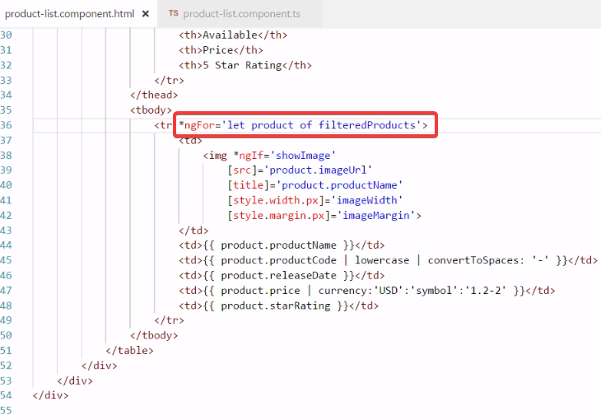

Let’s give it a try.

Now in the next module we’ll see how to build components designed to be nested within other components, and will discover how to established communication between the nested component and its container component.



We can nest our components. We can nest a component within another component, and nest that component within yet another component, and so on. And because each component is fully encapsulated, we expose specific inputs and outputs for communication between a nested component and it’s container, allowing them to pass data back and forth.

There are two ways to use a component and display the component’s template. We can use a component as a directive. We saw how to use an component as an directive:

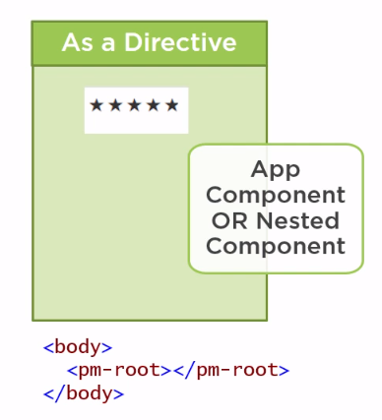

We saw how to use a component as a directive when we displayed the AppComponent template in the index.html file. The **pm-root** directive is defined as the AppComponent selector. The template is then displayed within the directive tags. We use this same technique with nested components.

Alternatively, we can use a component as a routing target, so it appears to the user that they’ve travelled to another view:

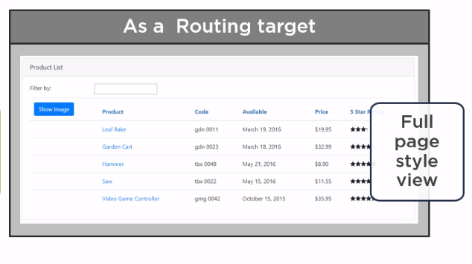

The template is then displayed in a full-page style view. We’ll use this technique later in this course to route to our Product List view. In this module we’ll learn how to make a nested component.

So, What makes our component nestable? Technically, any of our component could be nested if they have a selector defined in the Component decorator. But does it really make sense to nest a large view such as our product list? For our purpose, we’ll define a component as nestable if its template only manages a fragment of a larger view.